# OBIEE Installation 11.1.1.7.0 Installation and Confiuration

Pre-requisites

1. Loop back adapter configuration
2. RCU Schemas
3. Weblogic Server installation (in case of s/w only install). This step is not required in case enterprise installation
4. DB service up and running

# OBIEE Installation 11.1.1.7.0 Installation

Download all the required files from Oracle eDelivery or Oracle.com. Unzip all the files on the same folder.

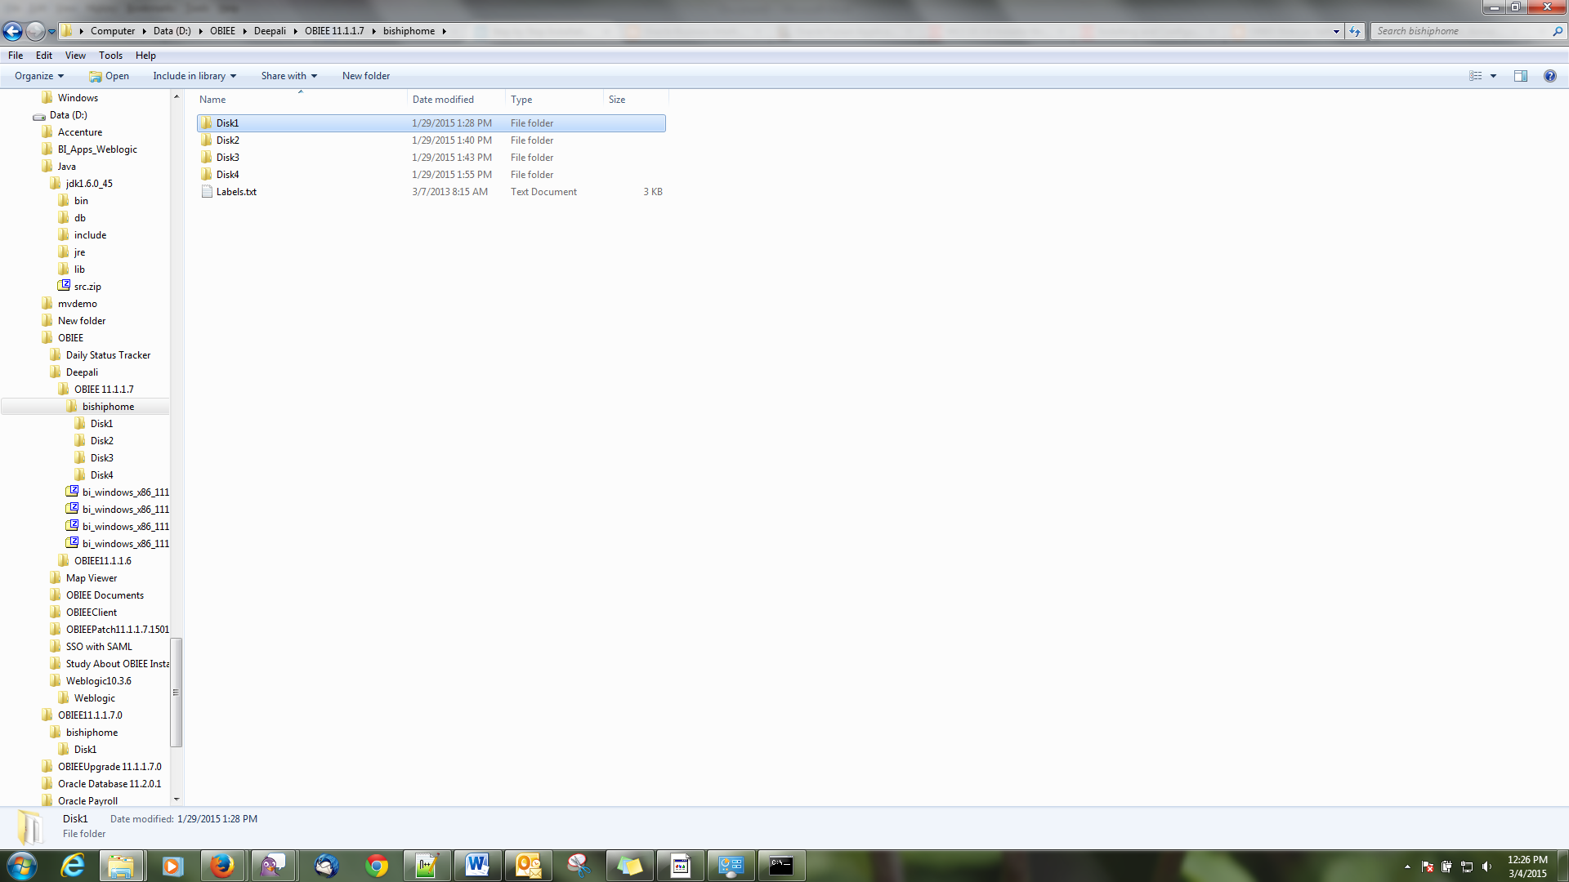

Open the Disk 1 Folder and then double click on setup

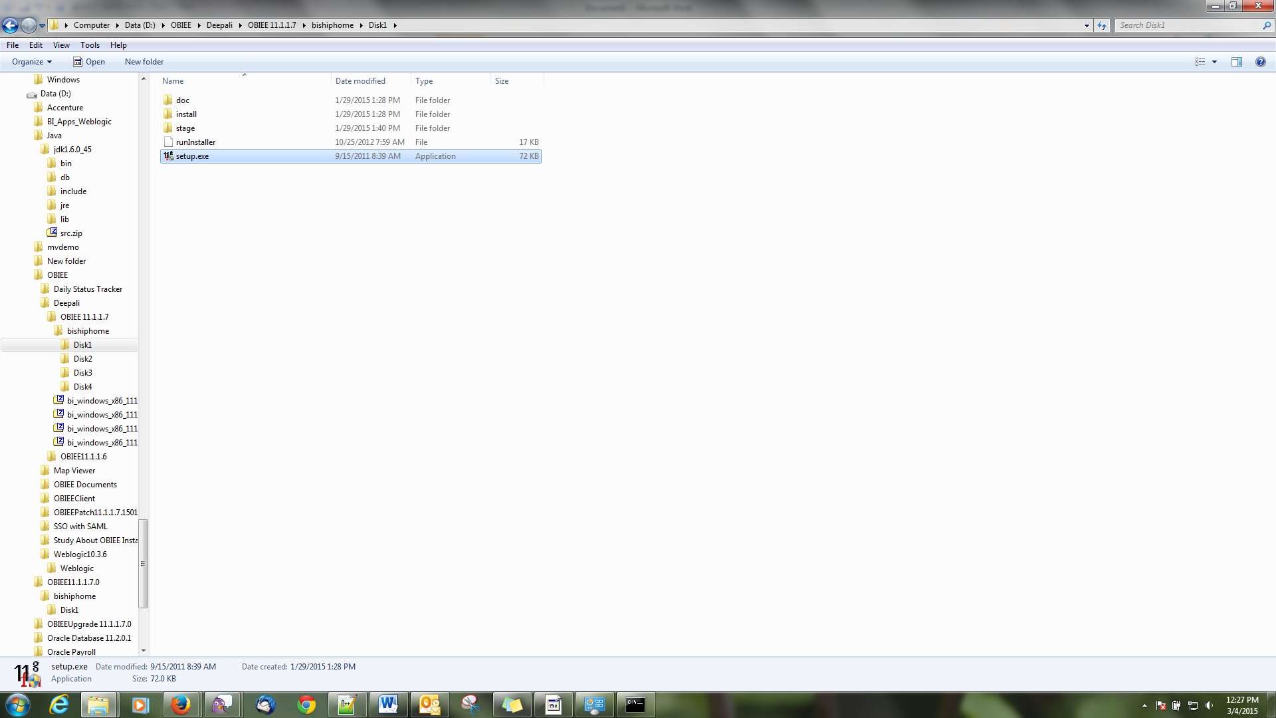

Right click and run as administrator

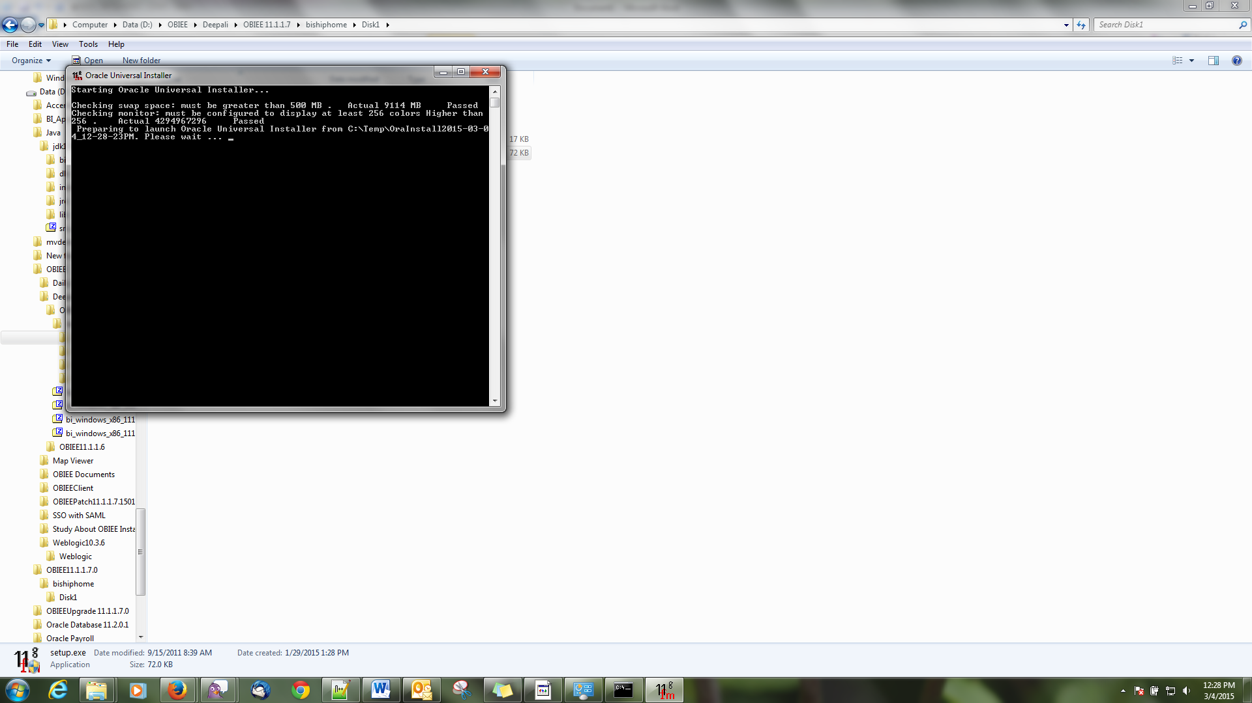

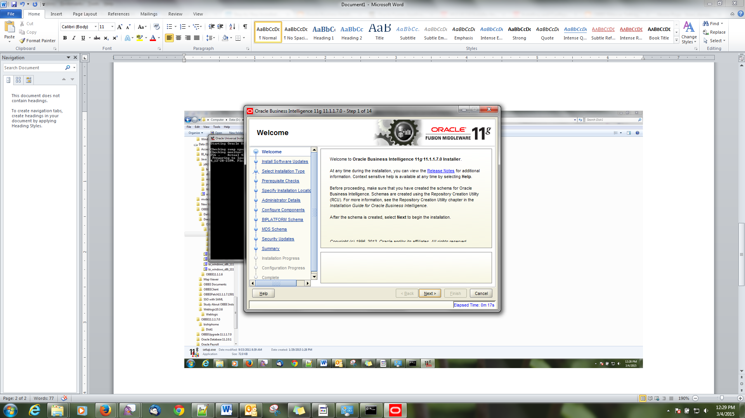

After the successful pre-check the first step of our OBIEE 11.1.1.7.0 starts with the below window. Just Click 'Next'

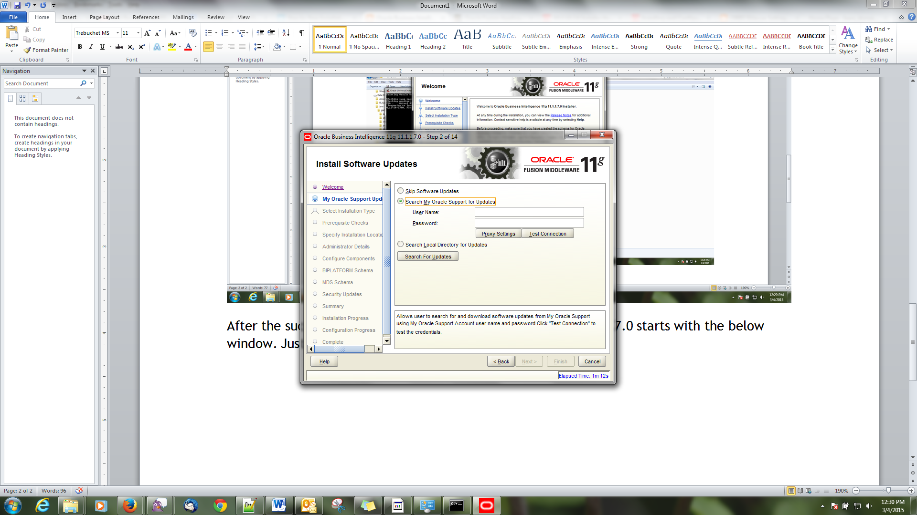

**Step2:**   
If you have oracle Support username and password then update then use that in this step or just select first option 'Skip Software updates' and click 'Next'

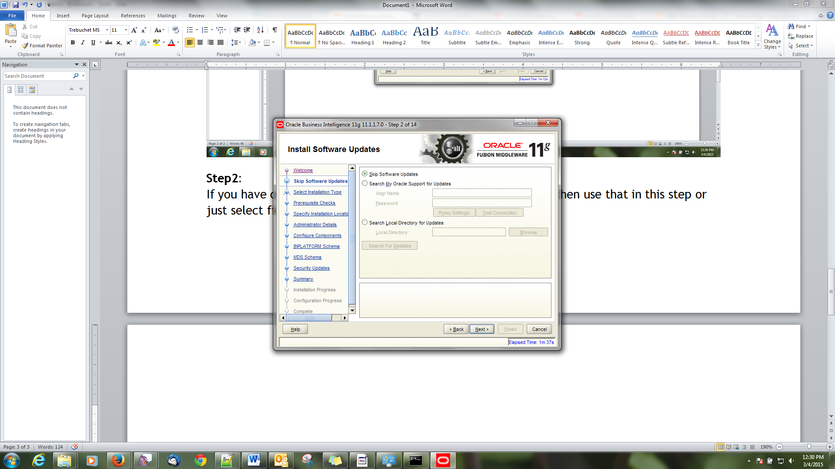

**Step3:**  
Select the appropriate installation step here. I am going to install all the component of BI so selected here 'Enterprise Install' and then click 'Next'

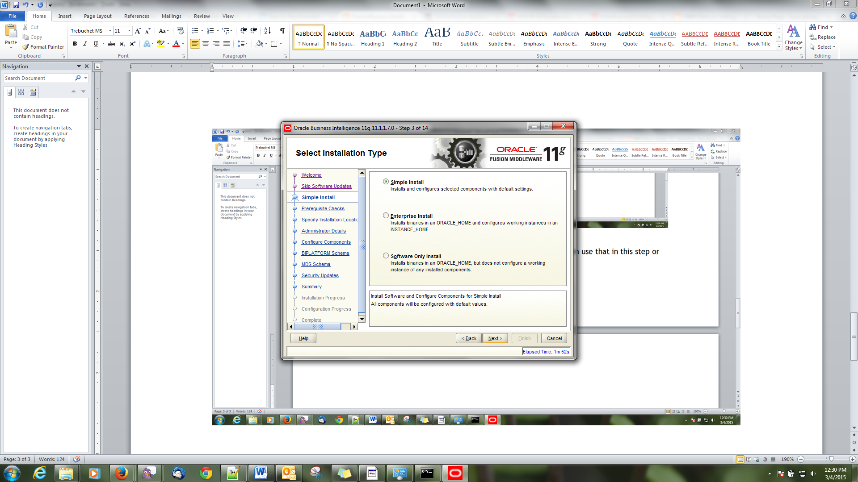

Choose “software only install”

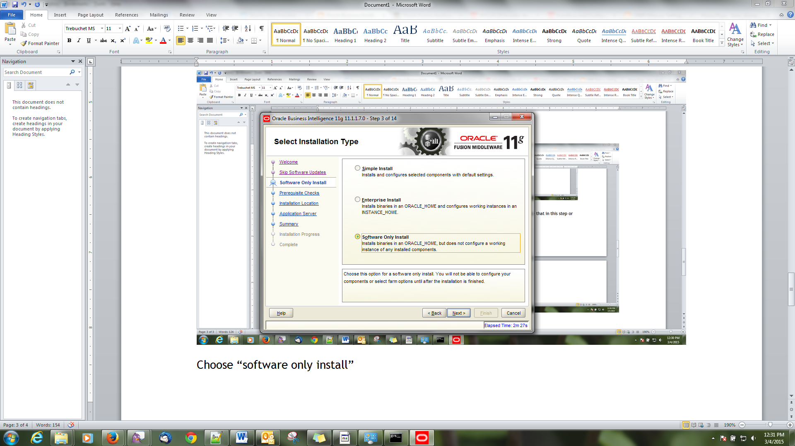

**Step4:**  
This step will just check operating system certification and physical memory. Just click 'Next' after the check passed through

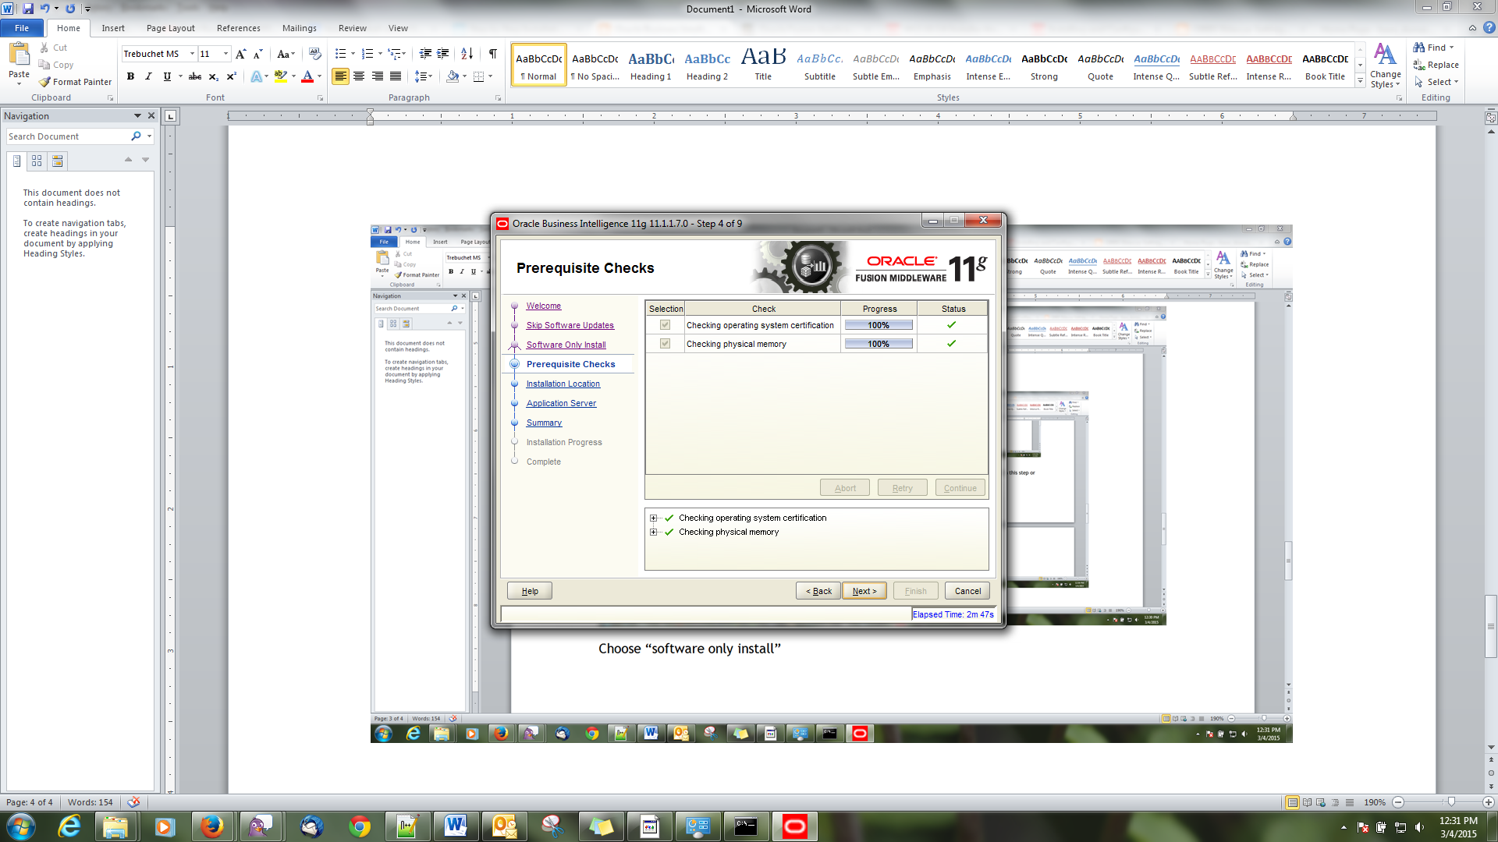

**Step5:**  
As It is a new installation, select the option 'Create New BI System' and type password for weblogic User.  
Note: Save or remember the password because this is the password going to be used to access BI system, EM, Console and answers later on..  
and then click 'Next'

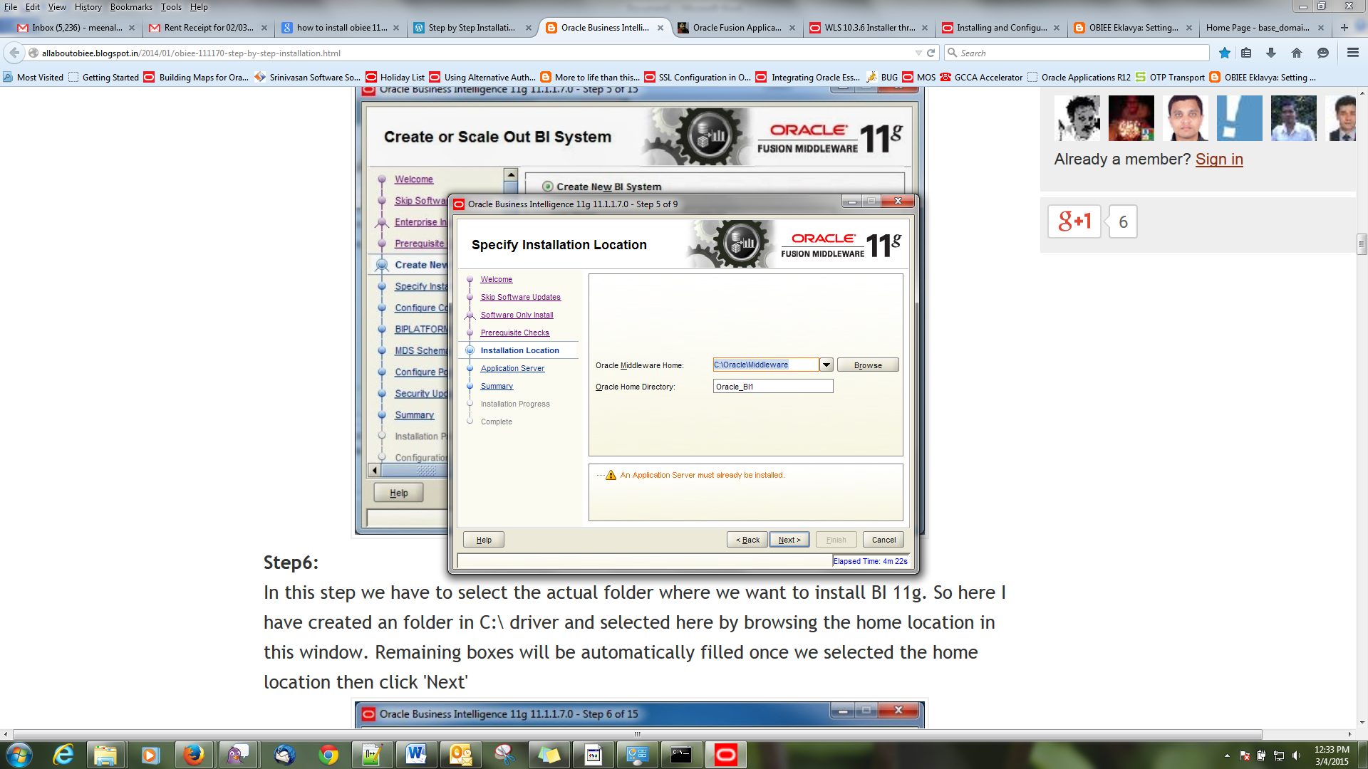

Oracle home path would be : c:\Oracle\Middleware

In the warning , you will get Application server must already be installed. Means that Oracle Weblogic server should already be installed for s/w ony installation

It should detect already installed weblogic server. If not try to manually configure weblogic server or troubleshoot the weblogic server

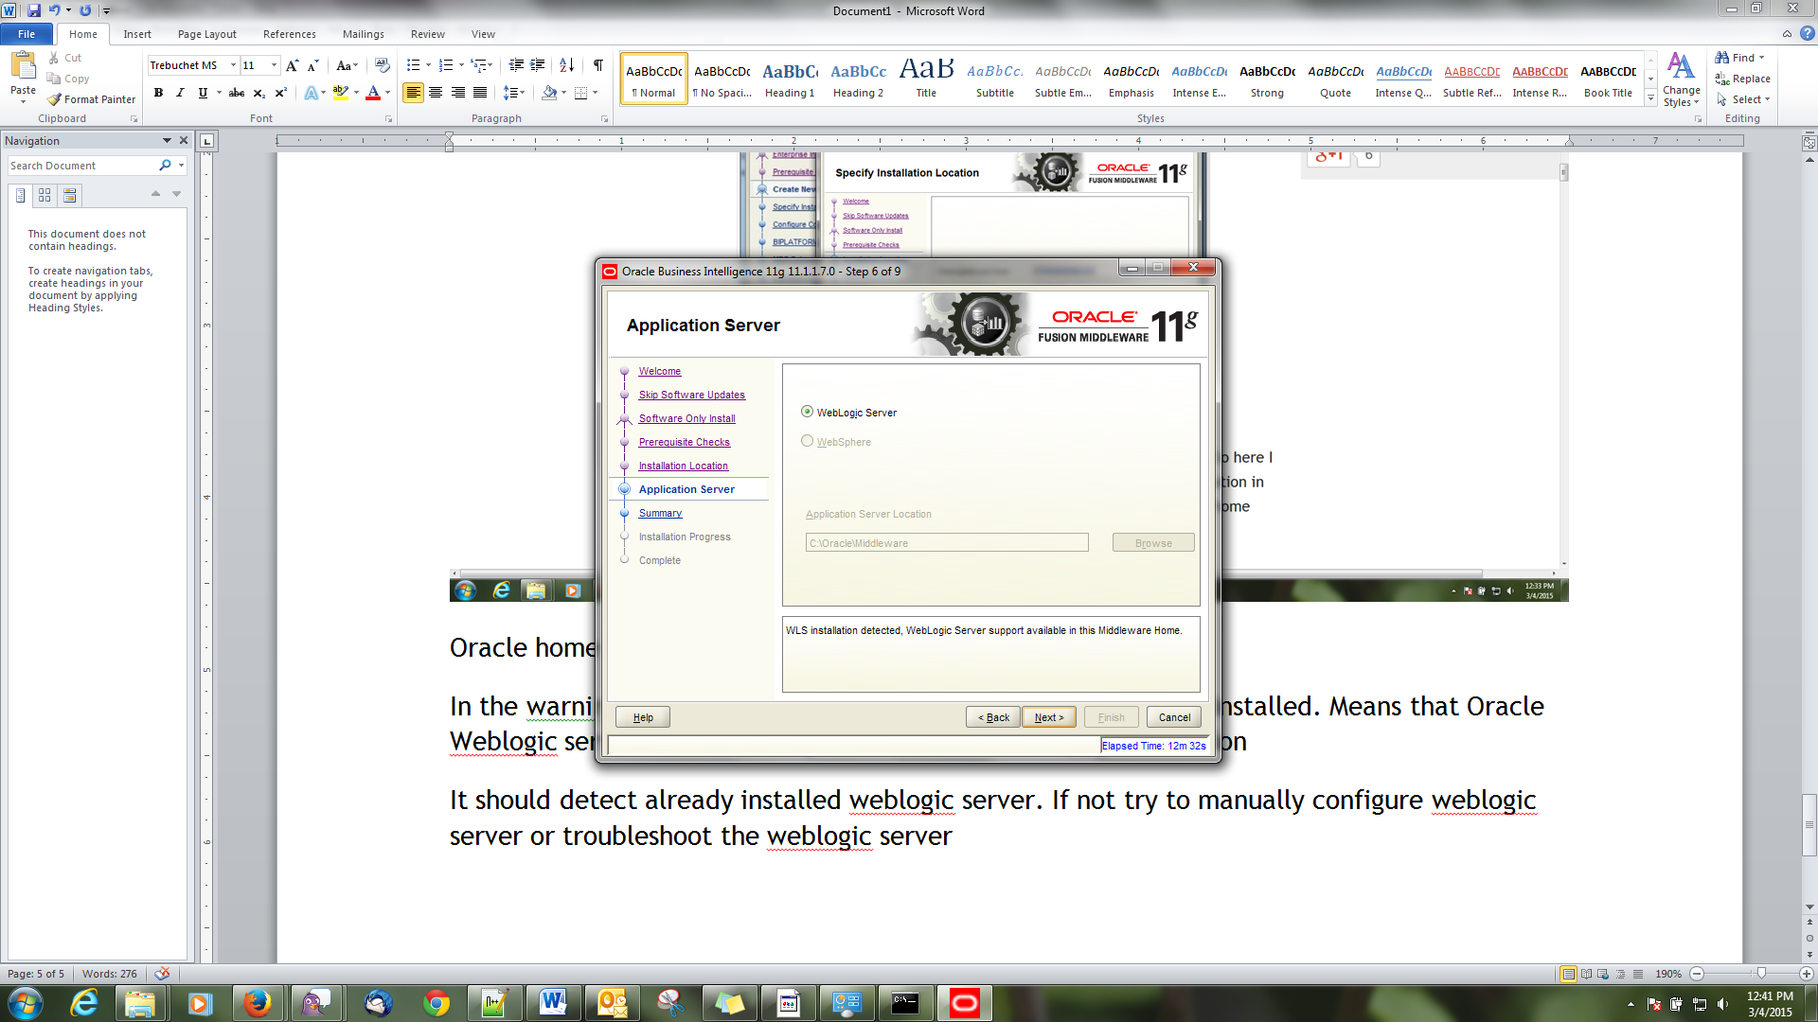

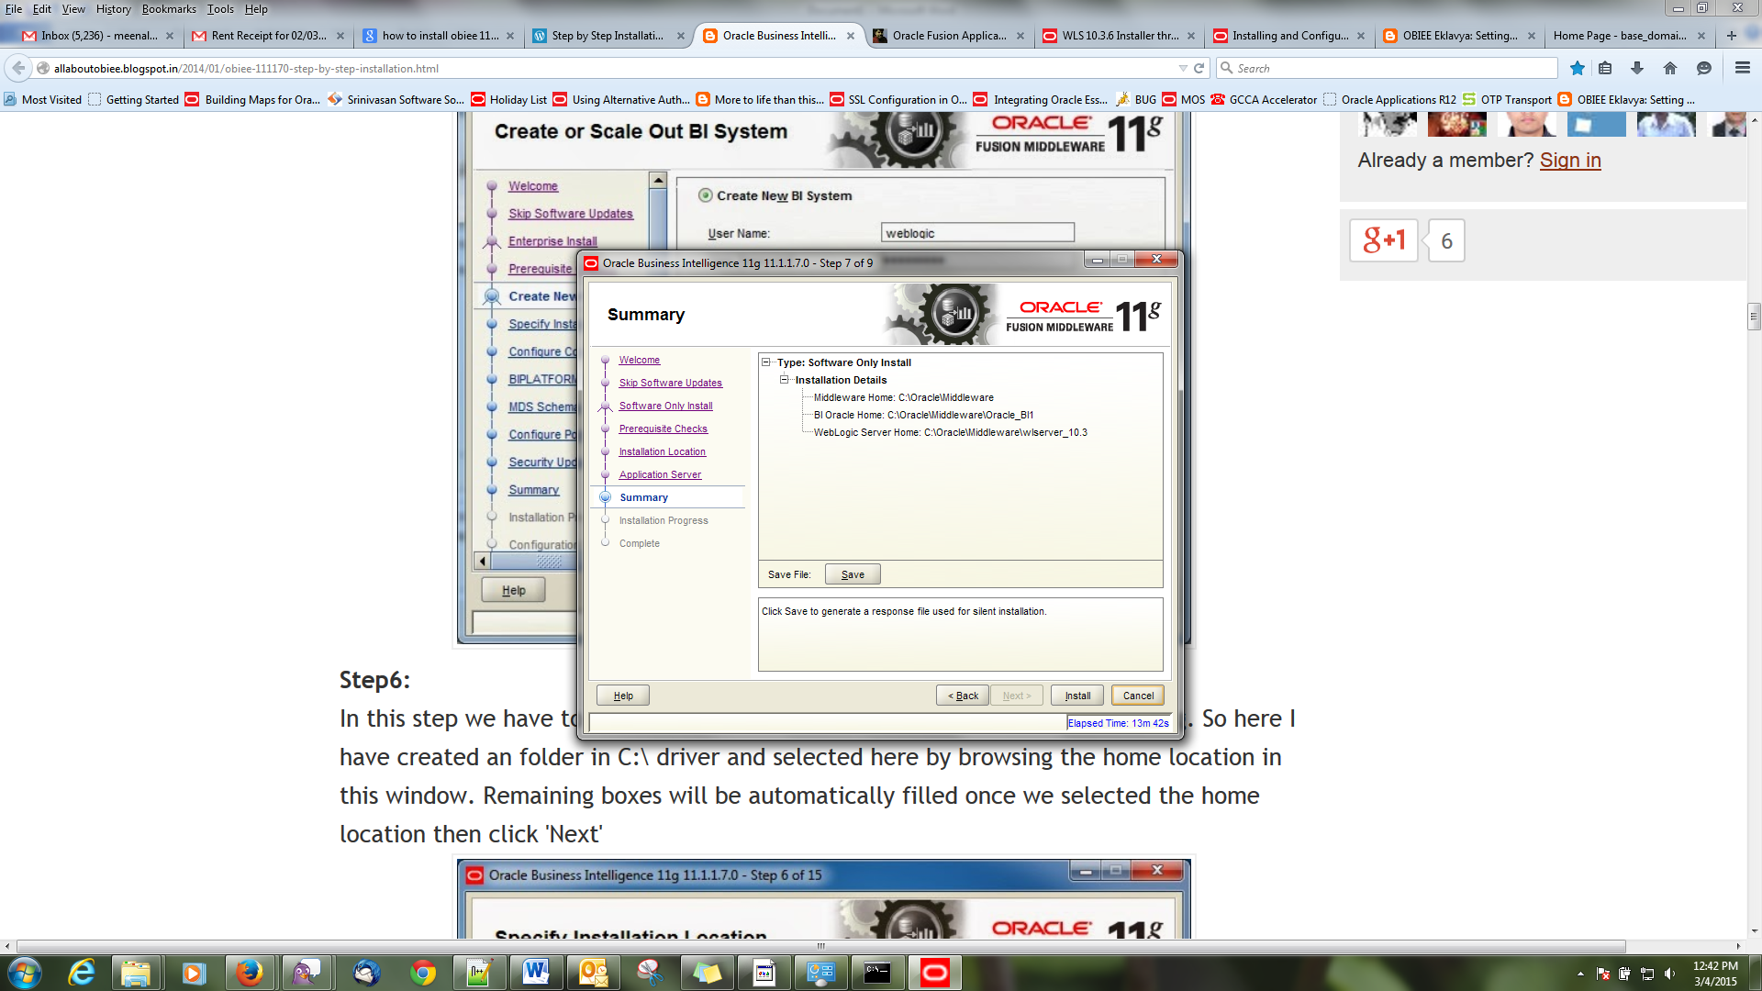

Click save for getting responses file . while troubleshooting , it will help you to understand where the issue arises.

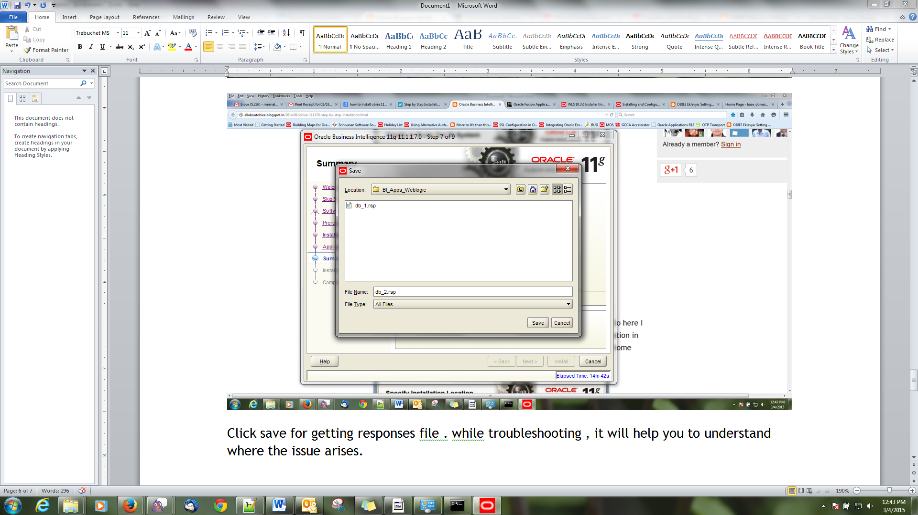  
click ok

Click ‘install’

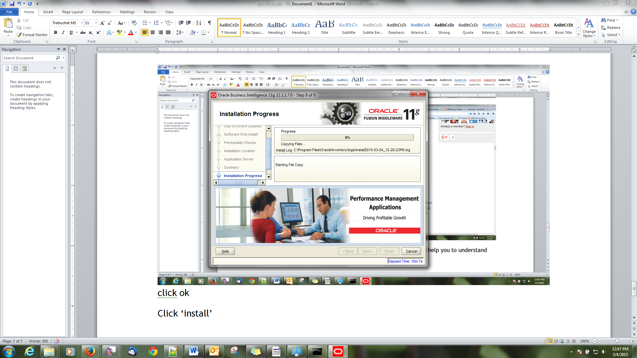

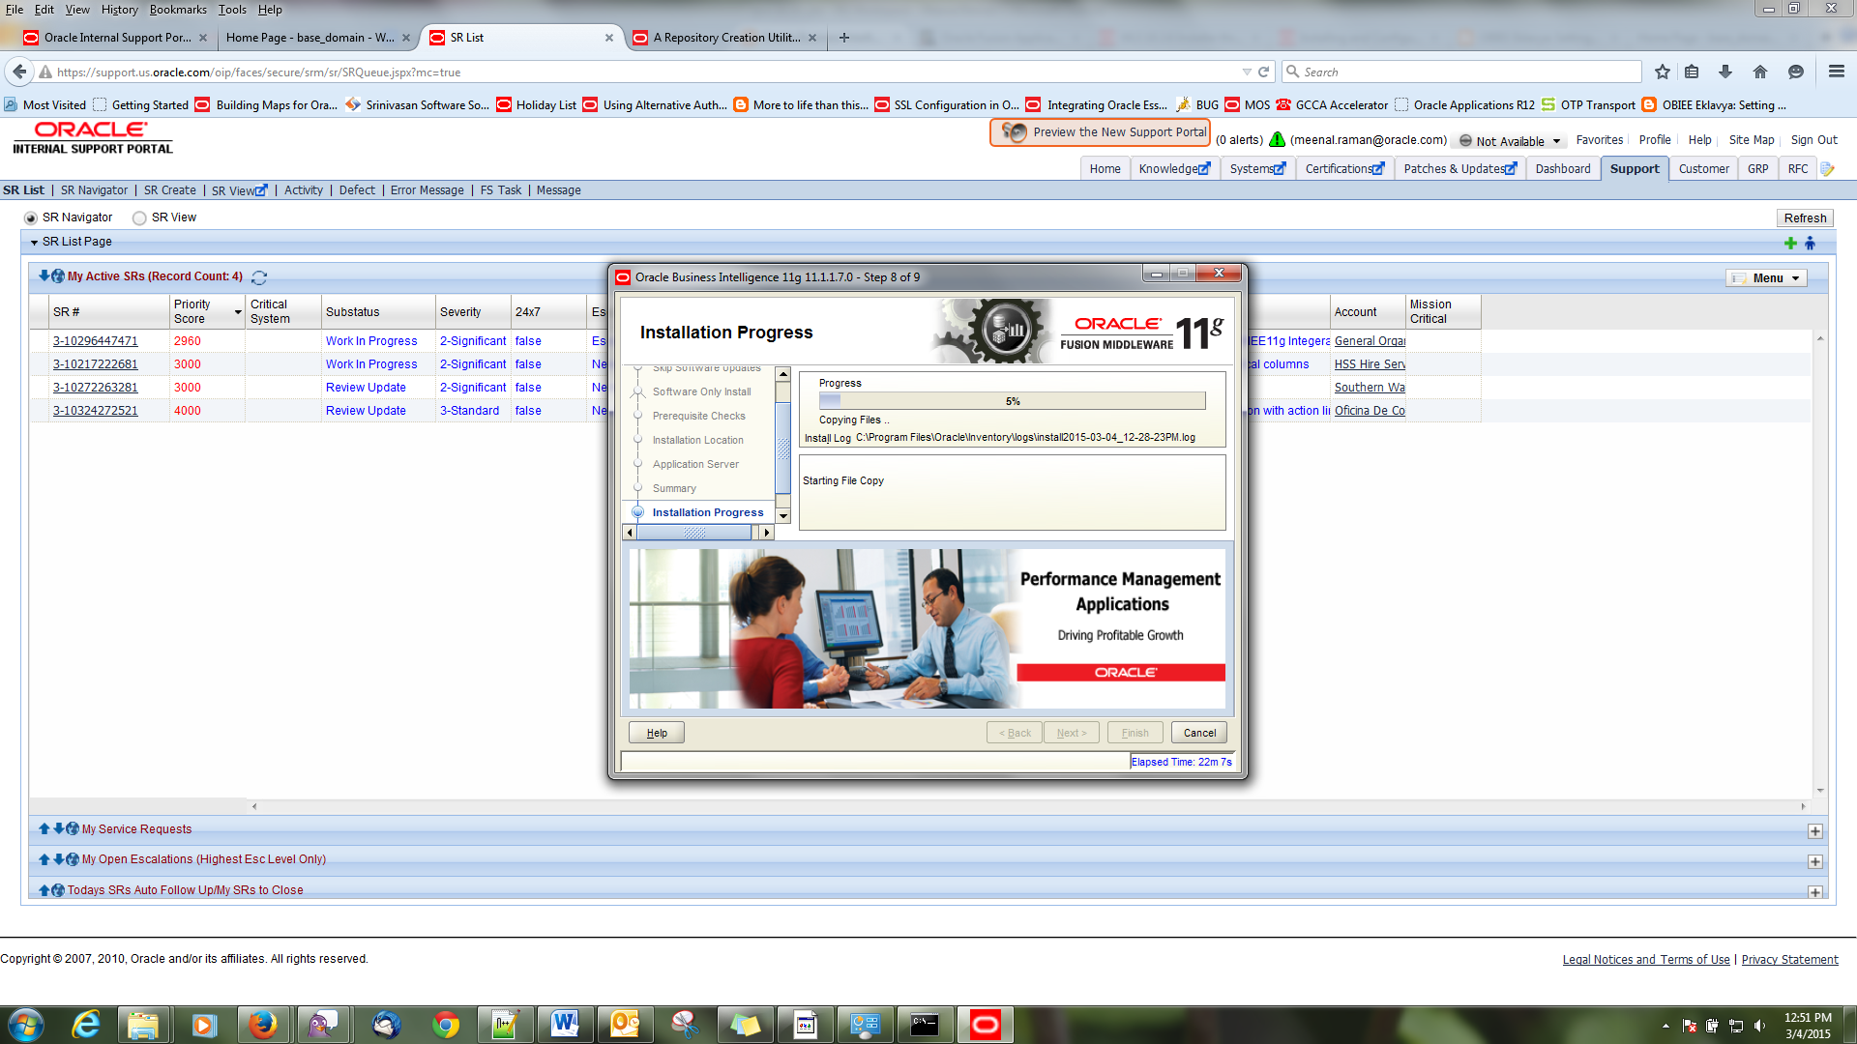

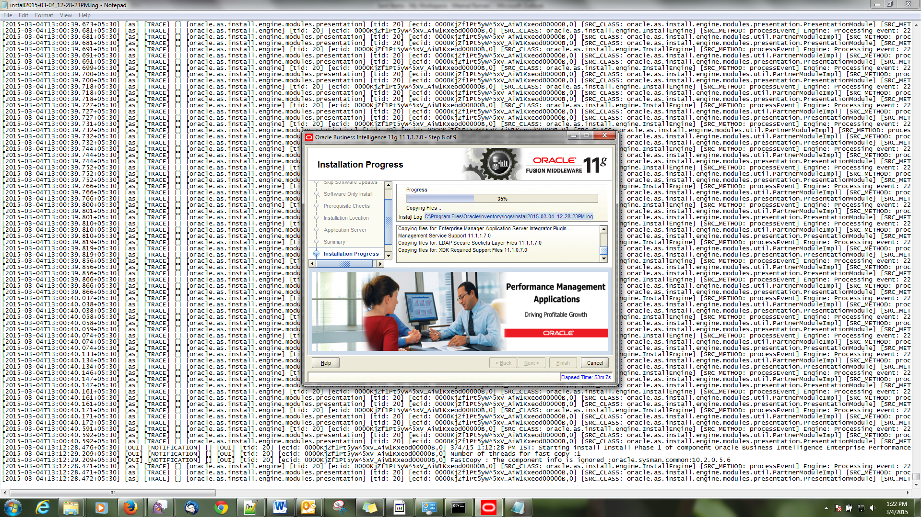

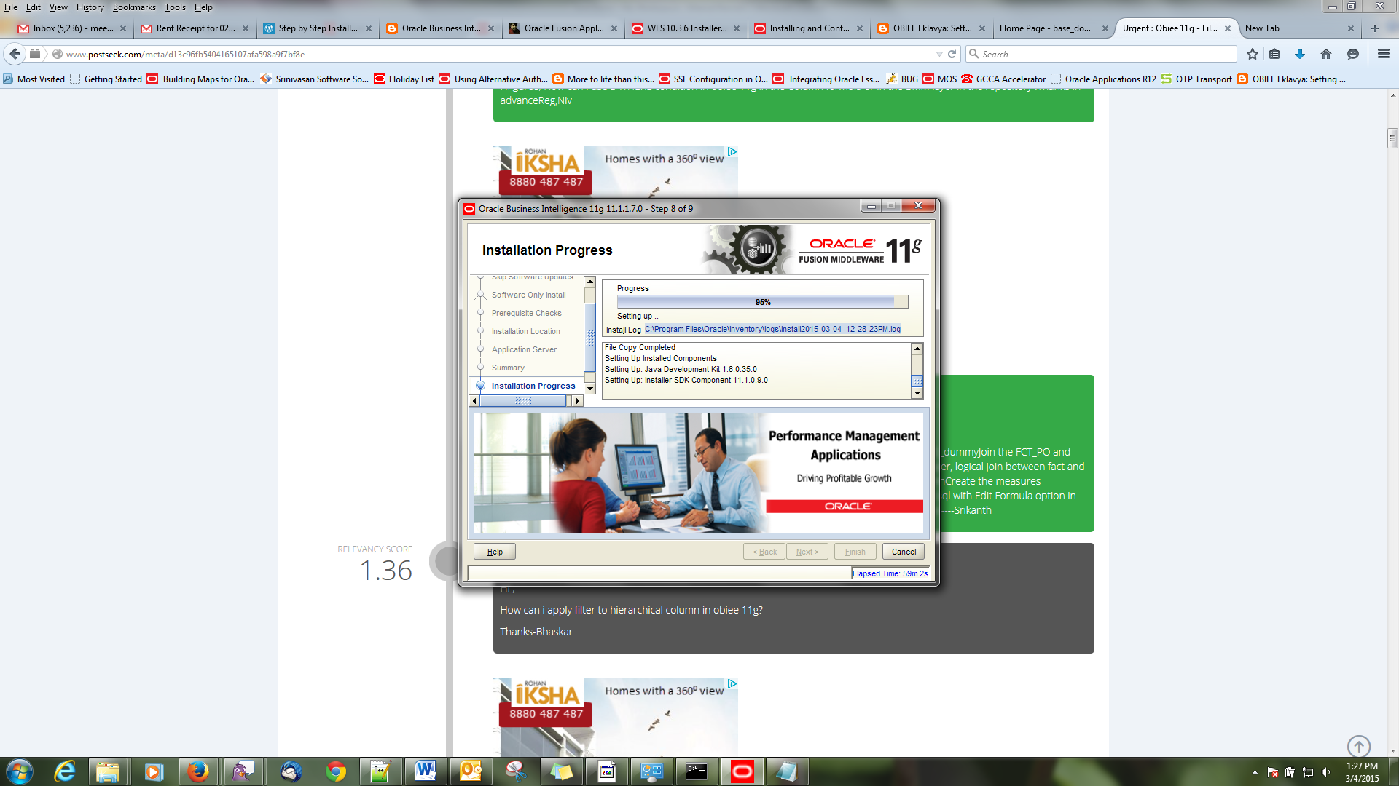

Go to Oracle home path and check what are the files modified

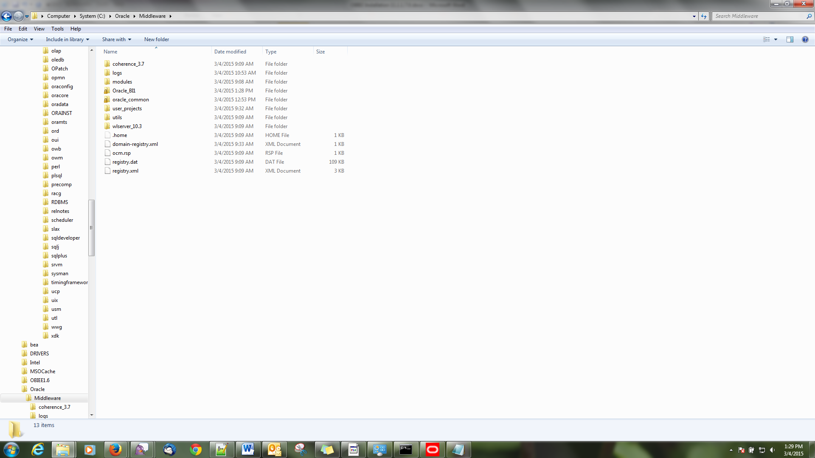

Oracle home – Oracle_BI1 and Oracle_common directories have been created during installation.

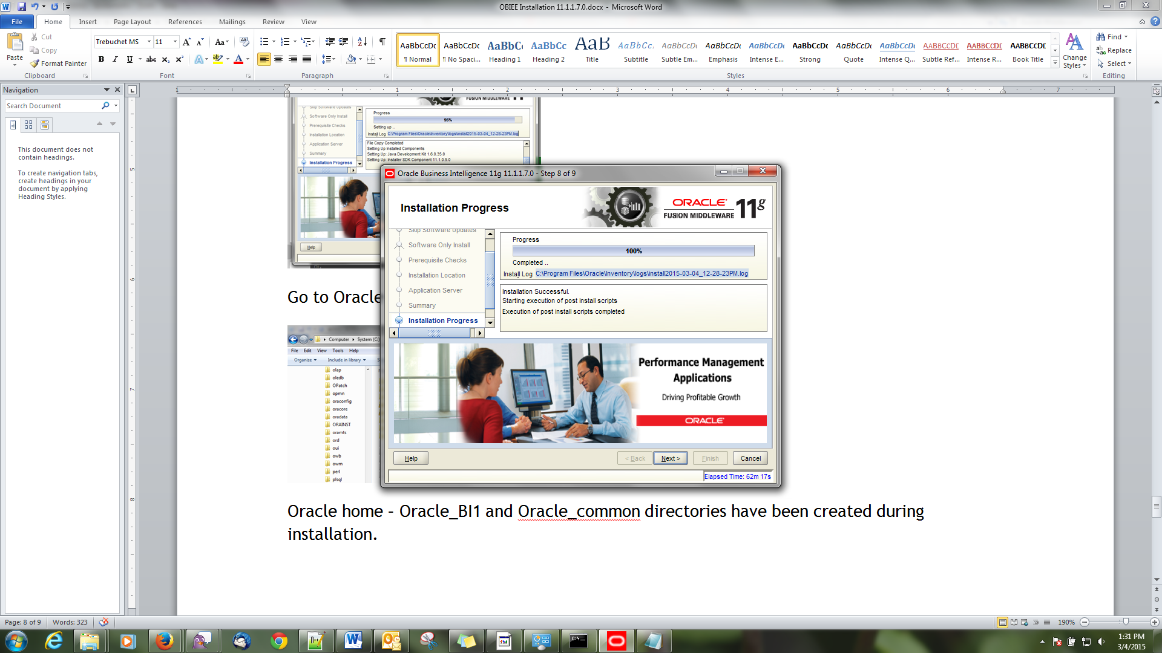once completed , you will get a message of installation successful.

Click “Next”

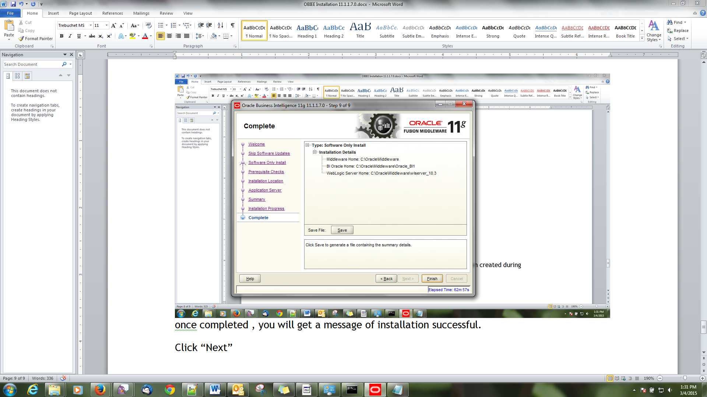

Click on Save to get responses file.

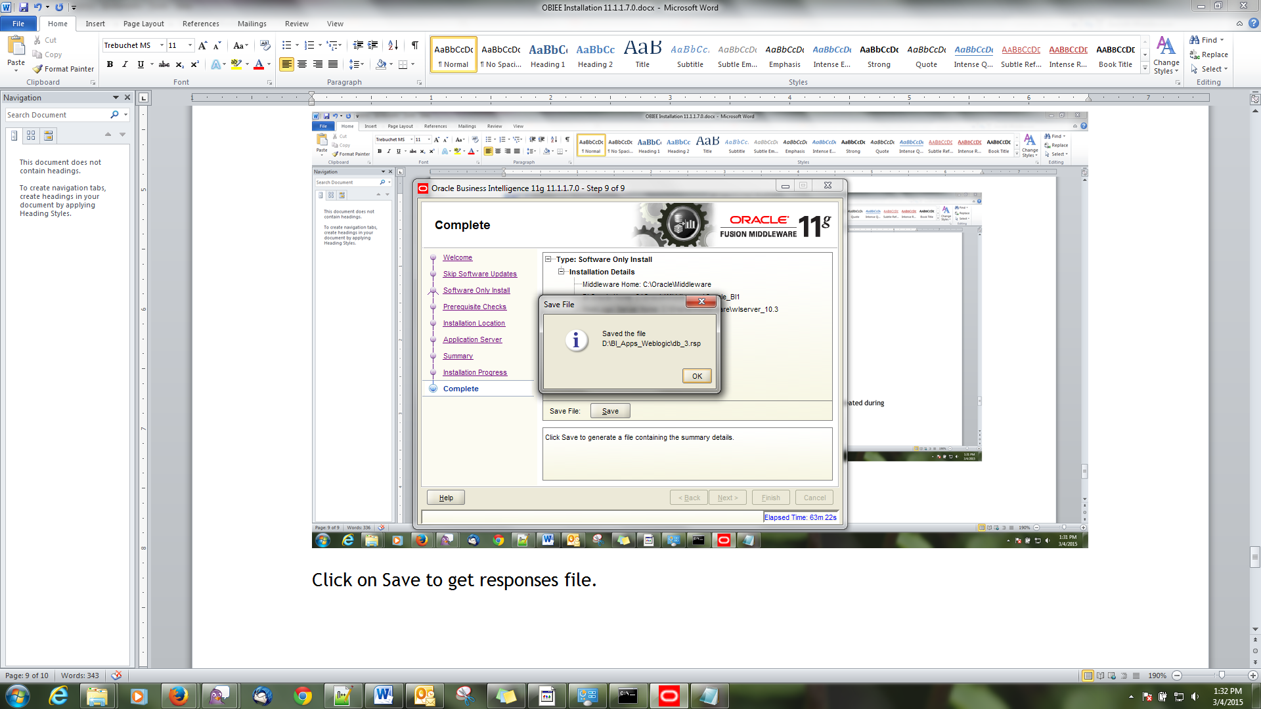

Click on OK

Click on Finish.

# OBIEE 11.1.1.7.0 Configuration Steps

Go to Oracle_Home path and navigate to the following path to run config.bat file

Path - C:\Oracle\Middleware\Oracle_BI1\bin , choose config.bat file

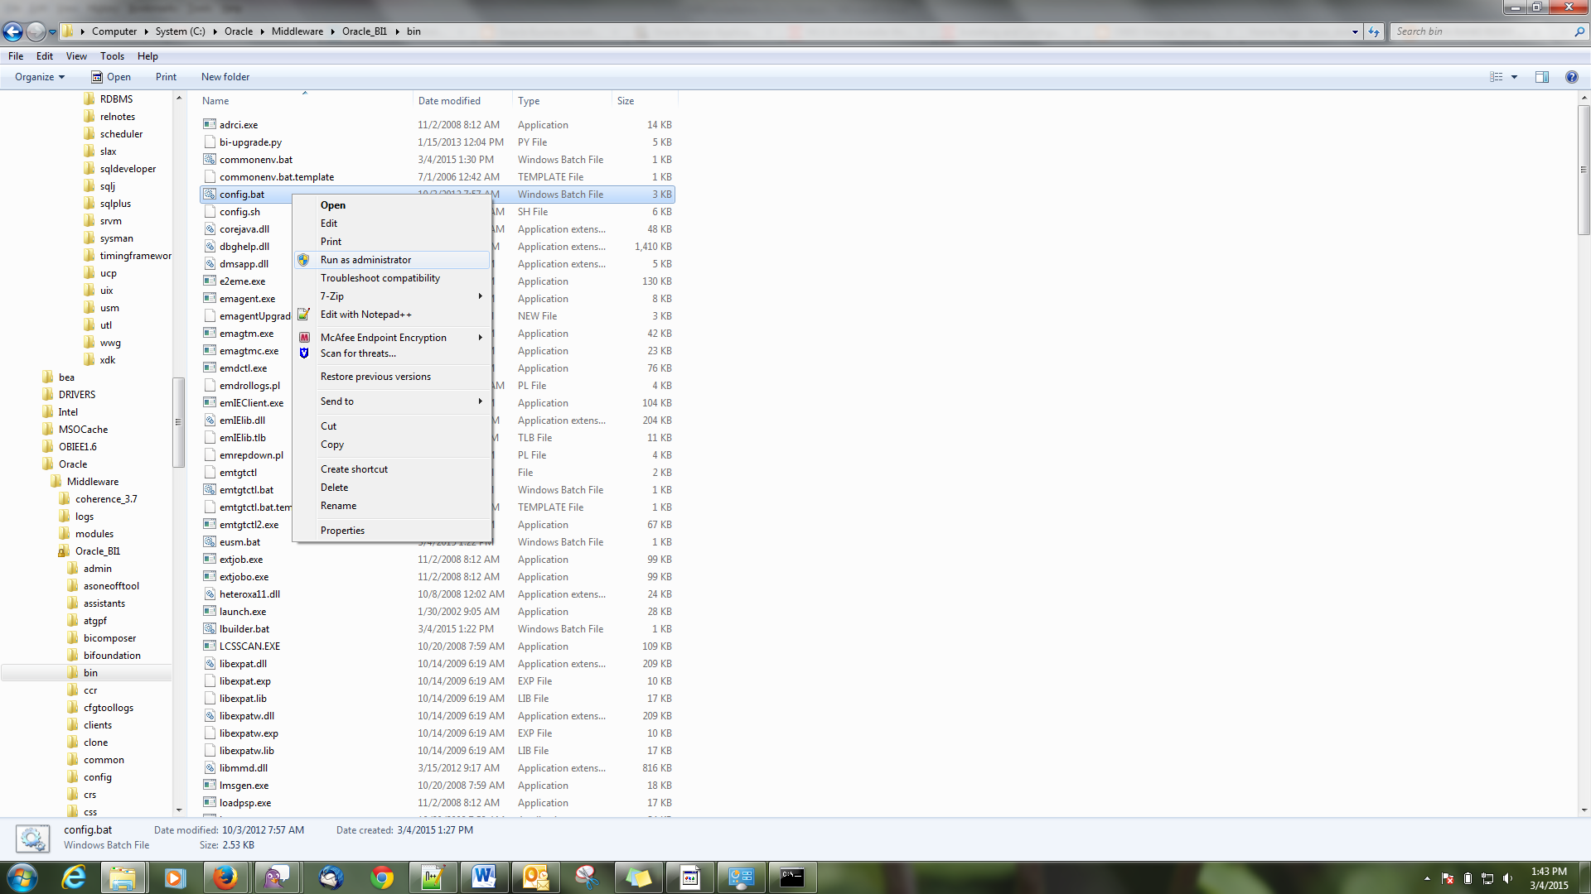

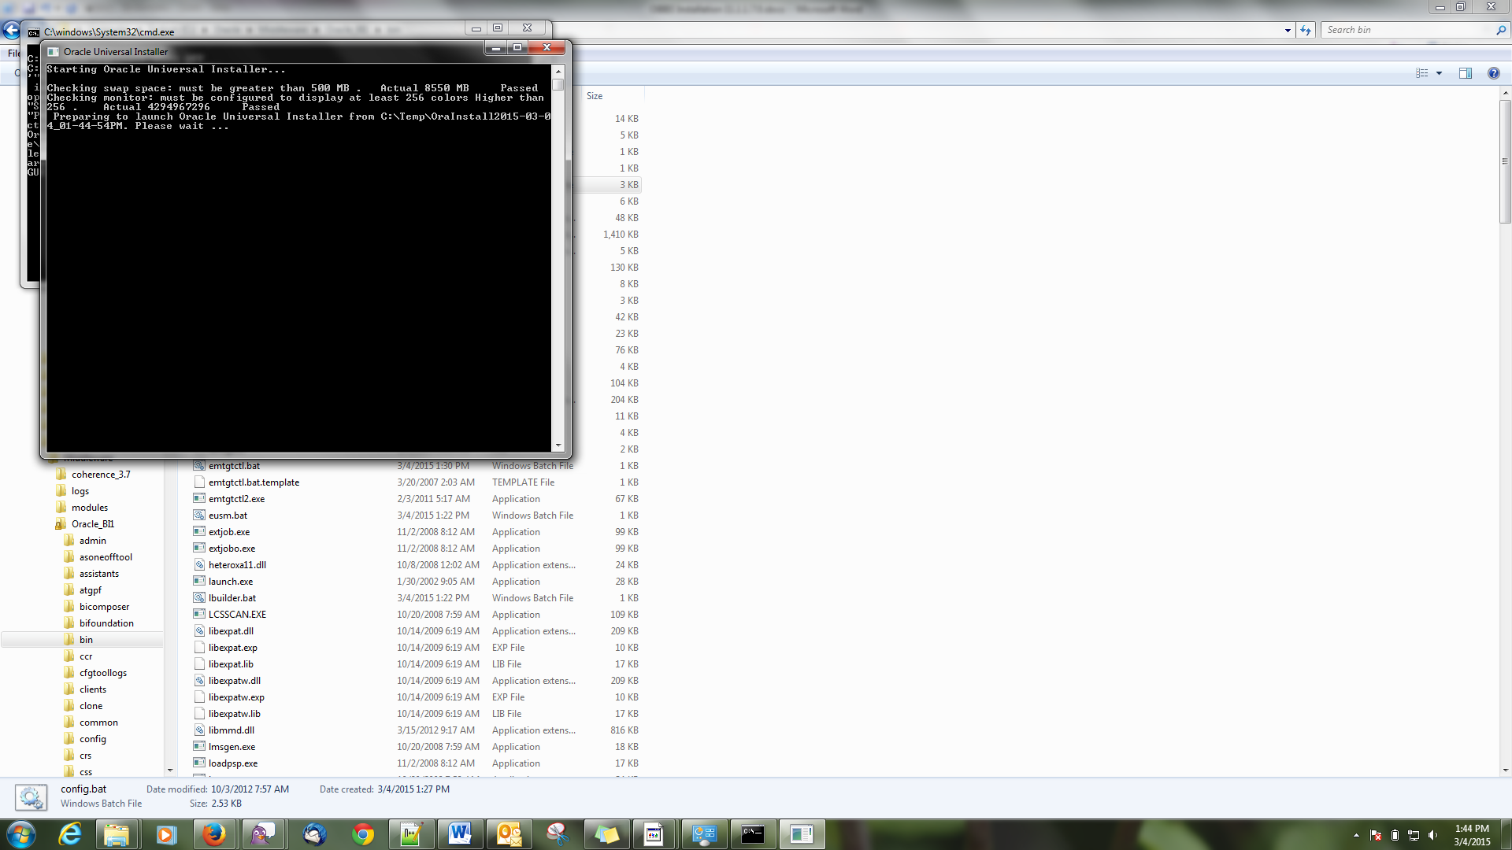

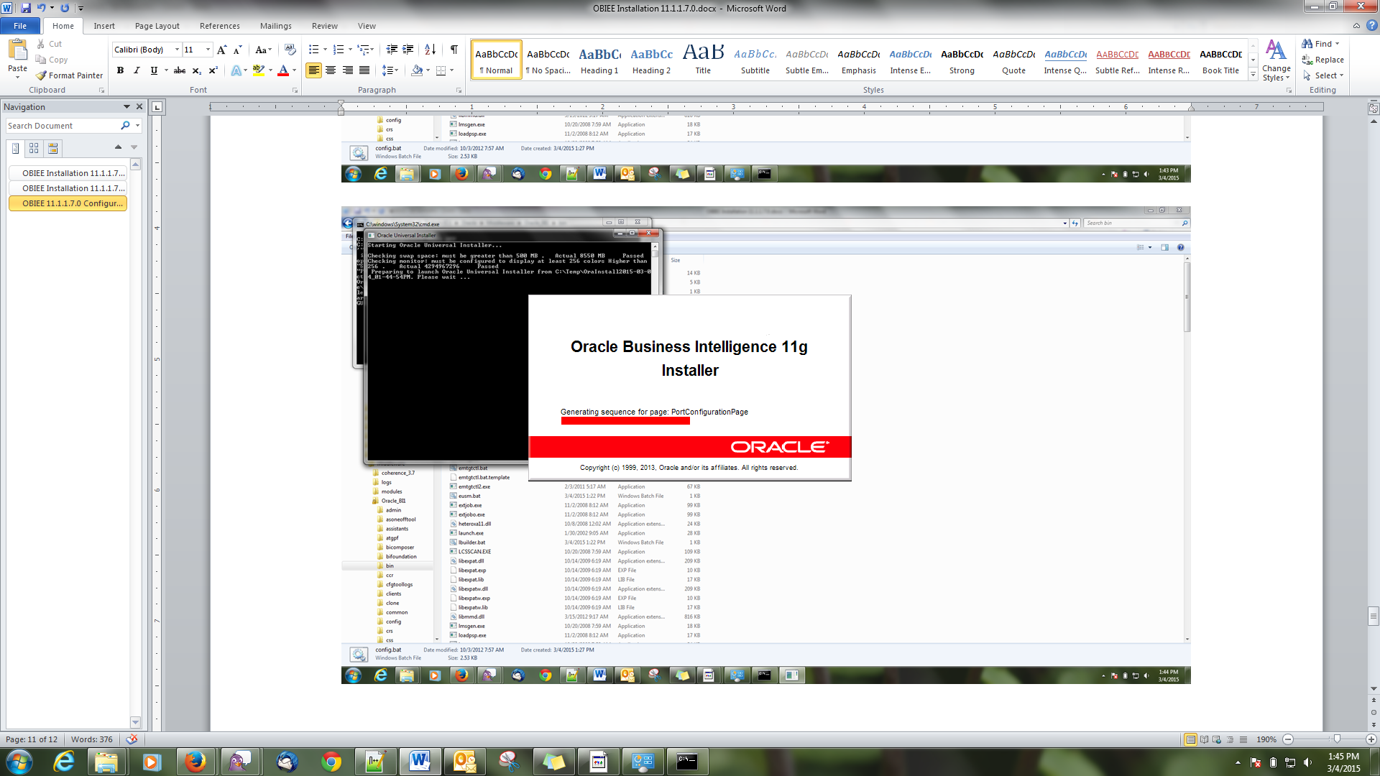

Welcome Screen

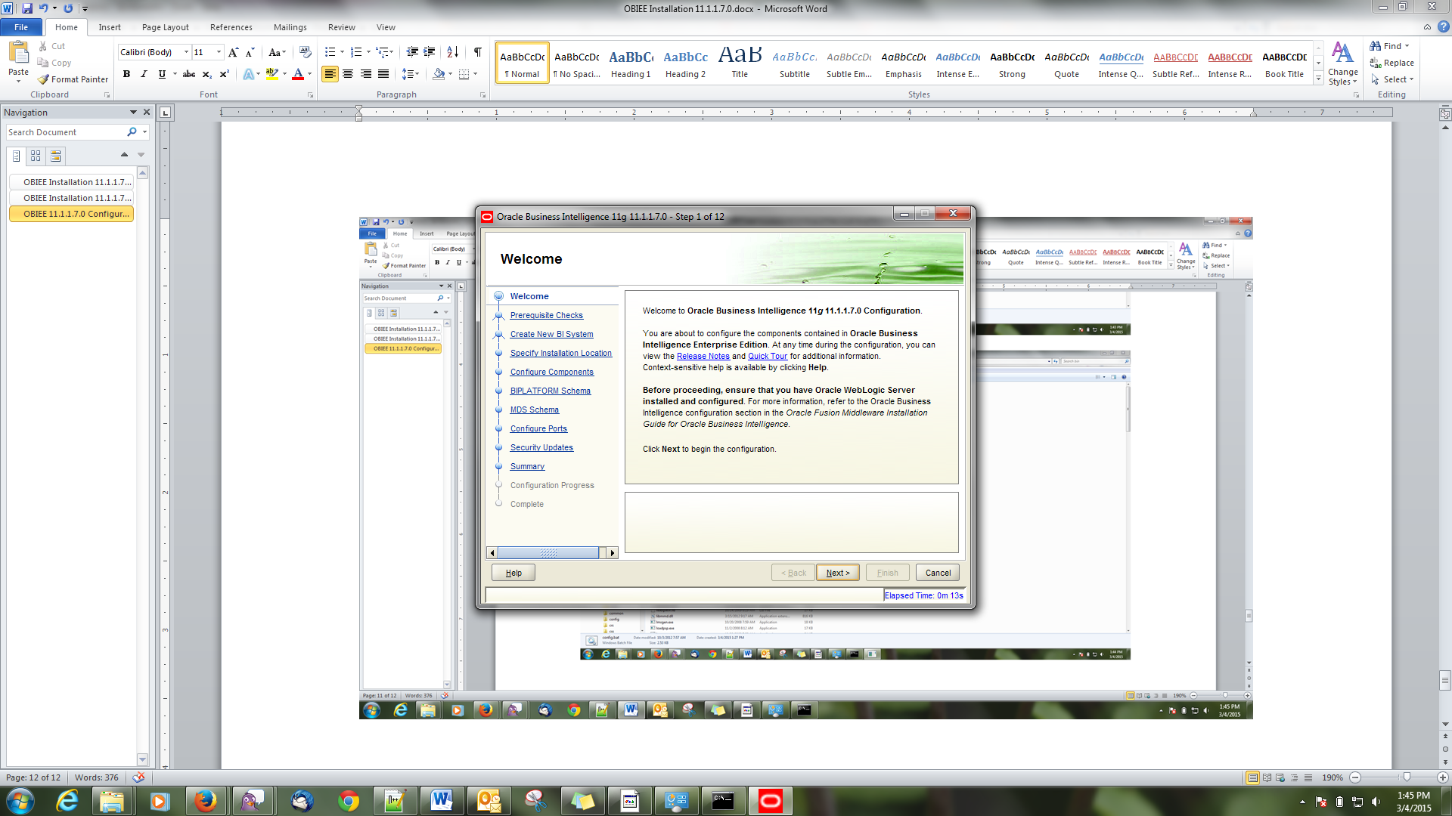

Prerequisite check

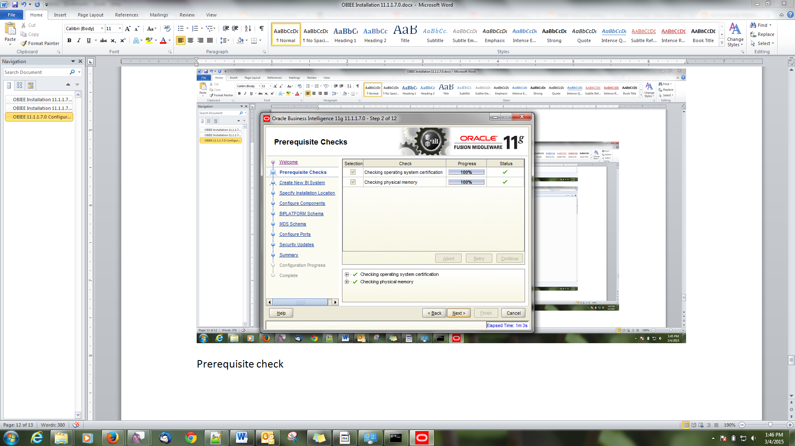

Create New BI System

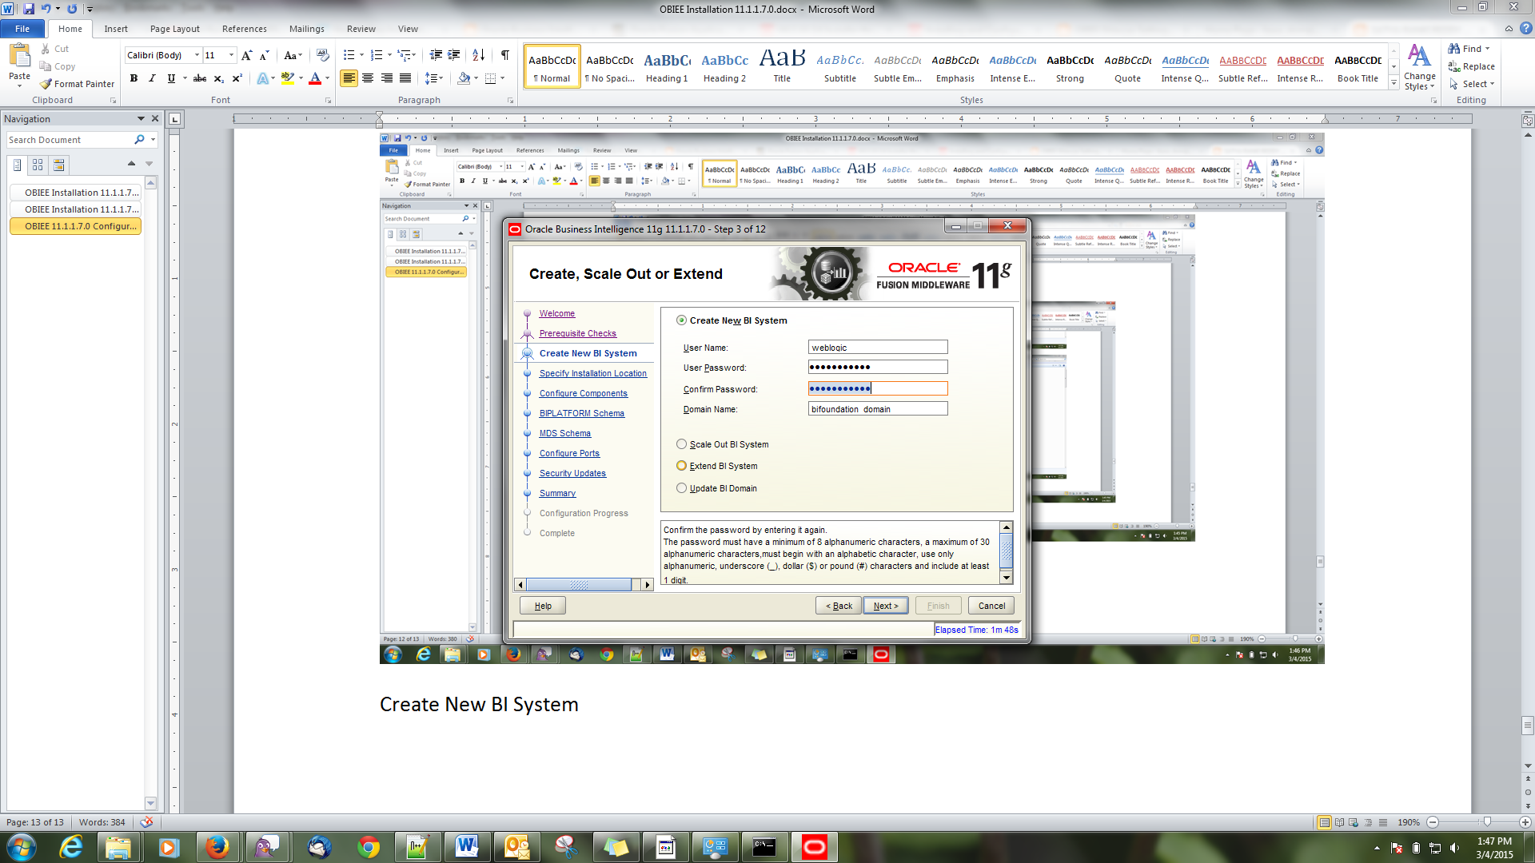

## Specify Installation Location

Give password for weblogic as “weblogic123”

Middleware Home = C:\Oracle\Middleware

Oracle Home = C:\Oracle\Middleware\Oracle_BI1

Weblogic Server Name = C:\Oracle\Middleware\wlserver_10.3

Domain home = C:\Oracle\Middleware\user_projects\domains\bifoundation_domain

Instance home = C:\Oracle\Middleware\instances\instance1

Instance name = instance1

## Configure Components

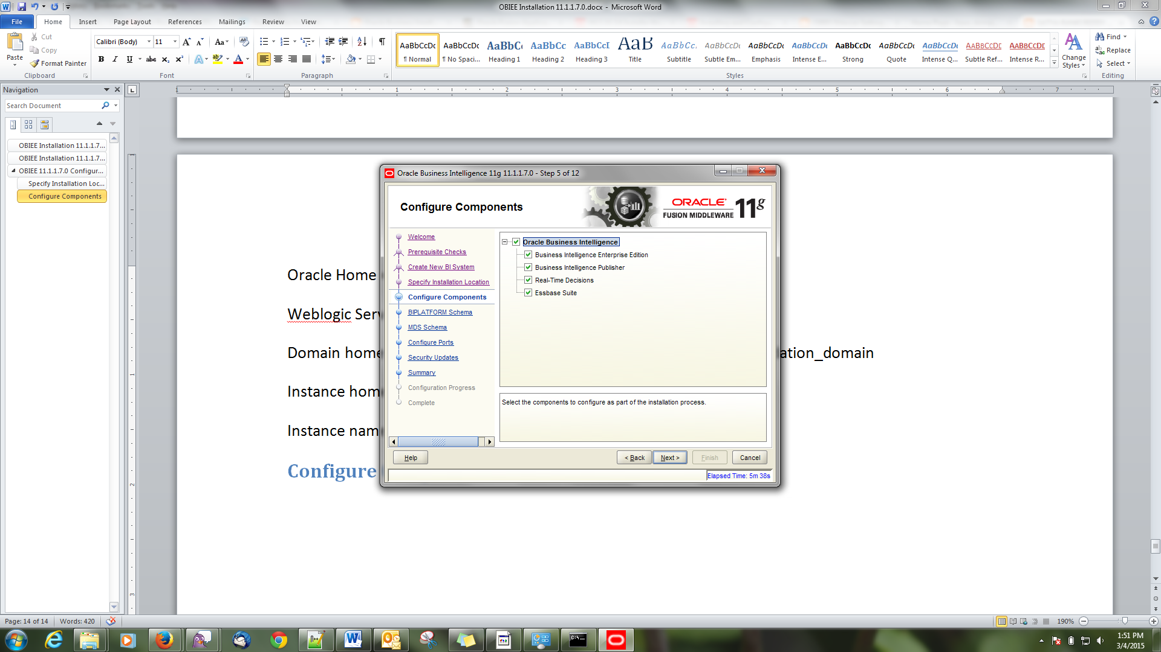

Remove Real – Time Decisions and keep remaining things

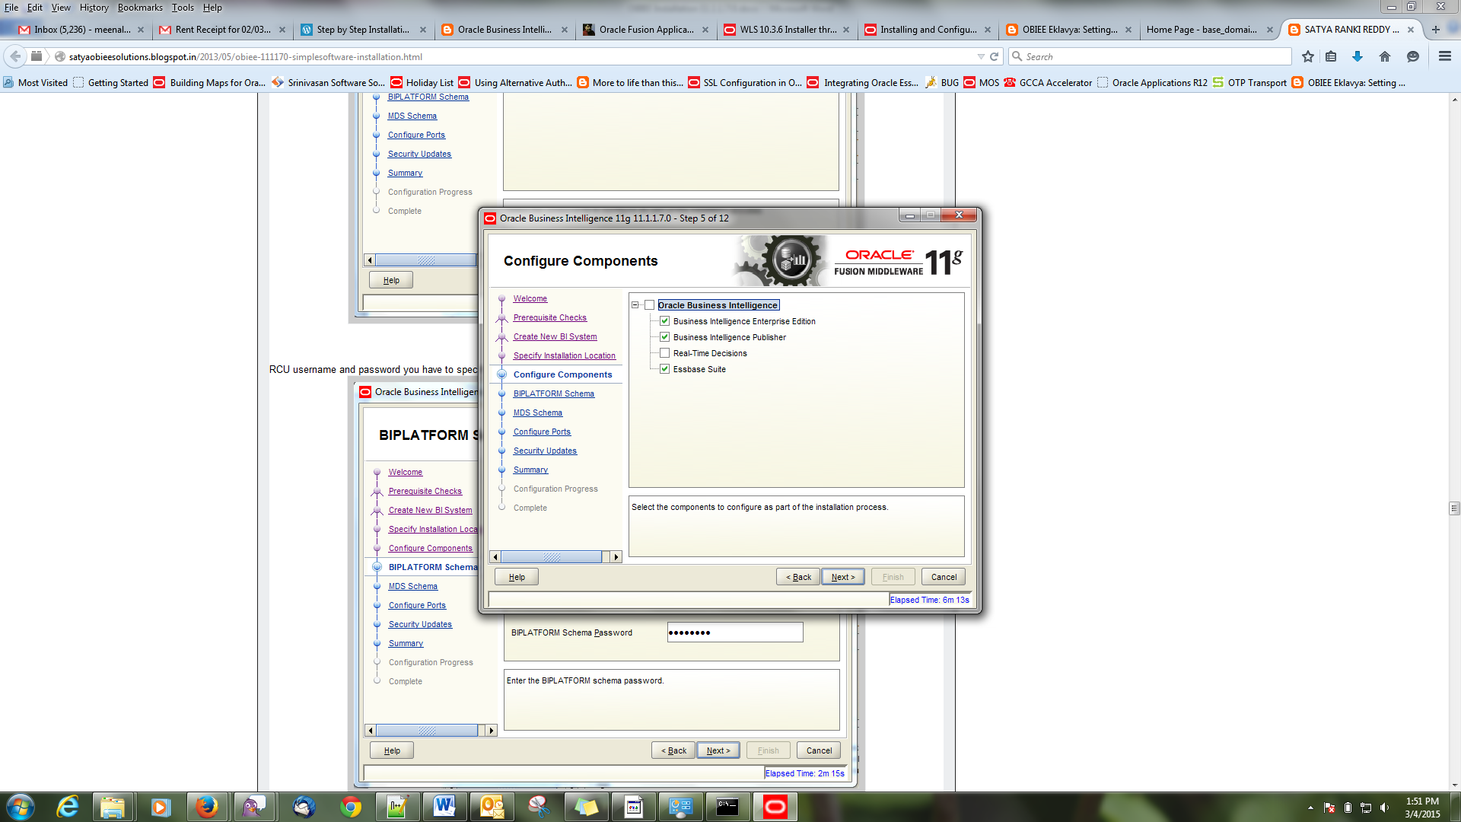

### BI_PLATFORM Schema

Connect String : localhost:1521:orcl.idc.oracle.com

Use the format for connect String – hostname:port:service_name

Bi Platform Schema user name: DEV_BIPLATFORM

Schema Password : Admin123

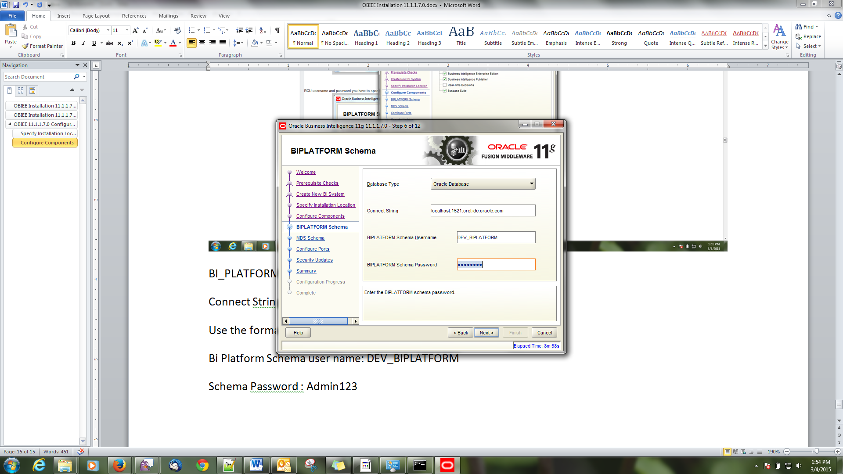

### MDS Schema

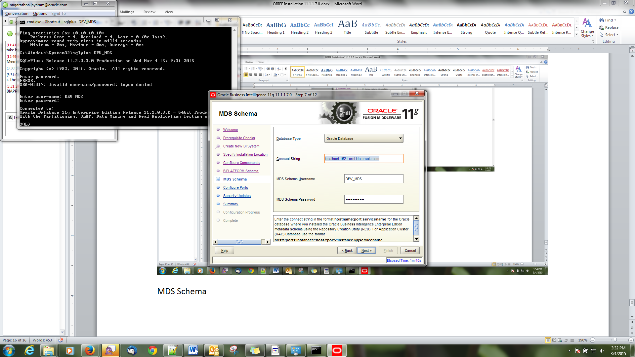

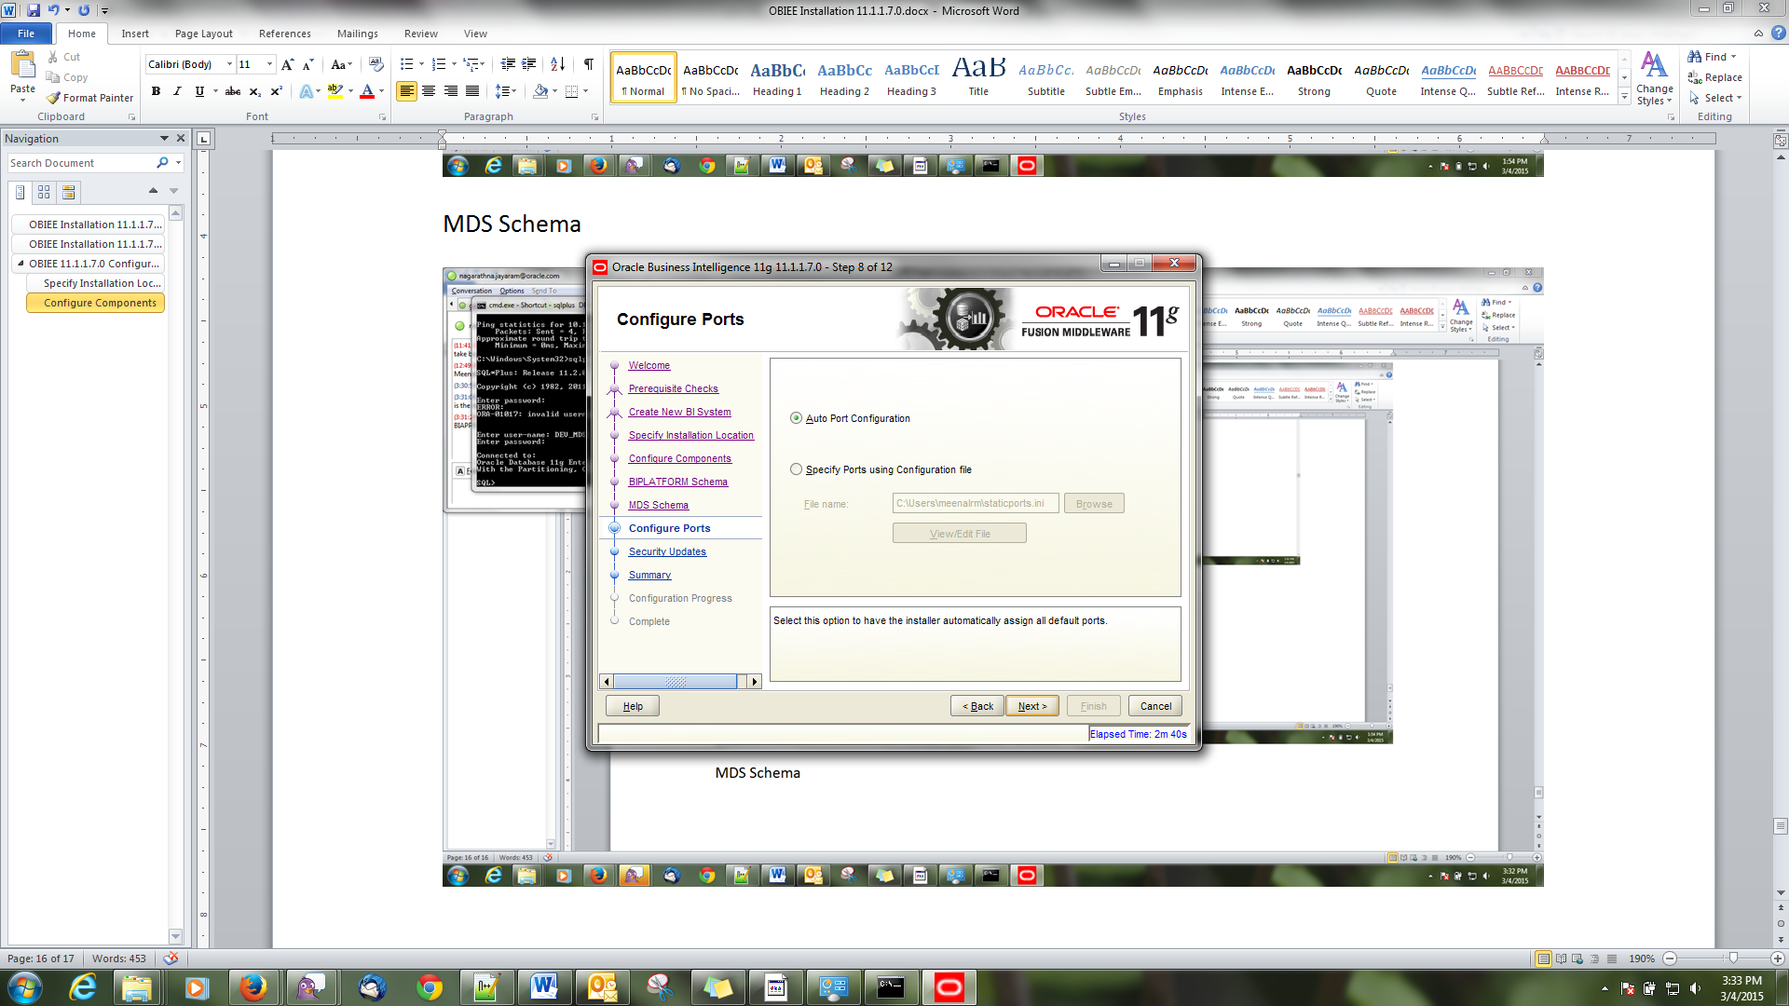

Choose Auto Port configuration

### Security Updates

Check – I donot wish to receive emails

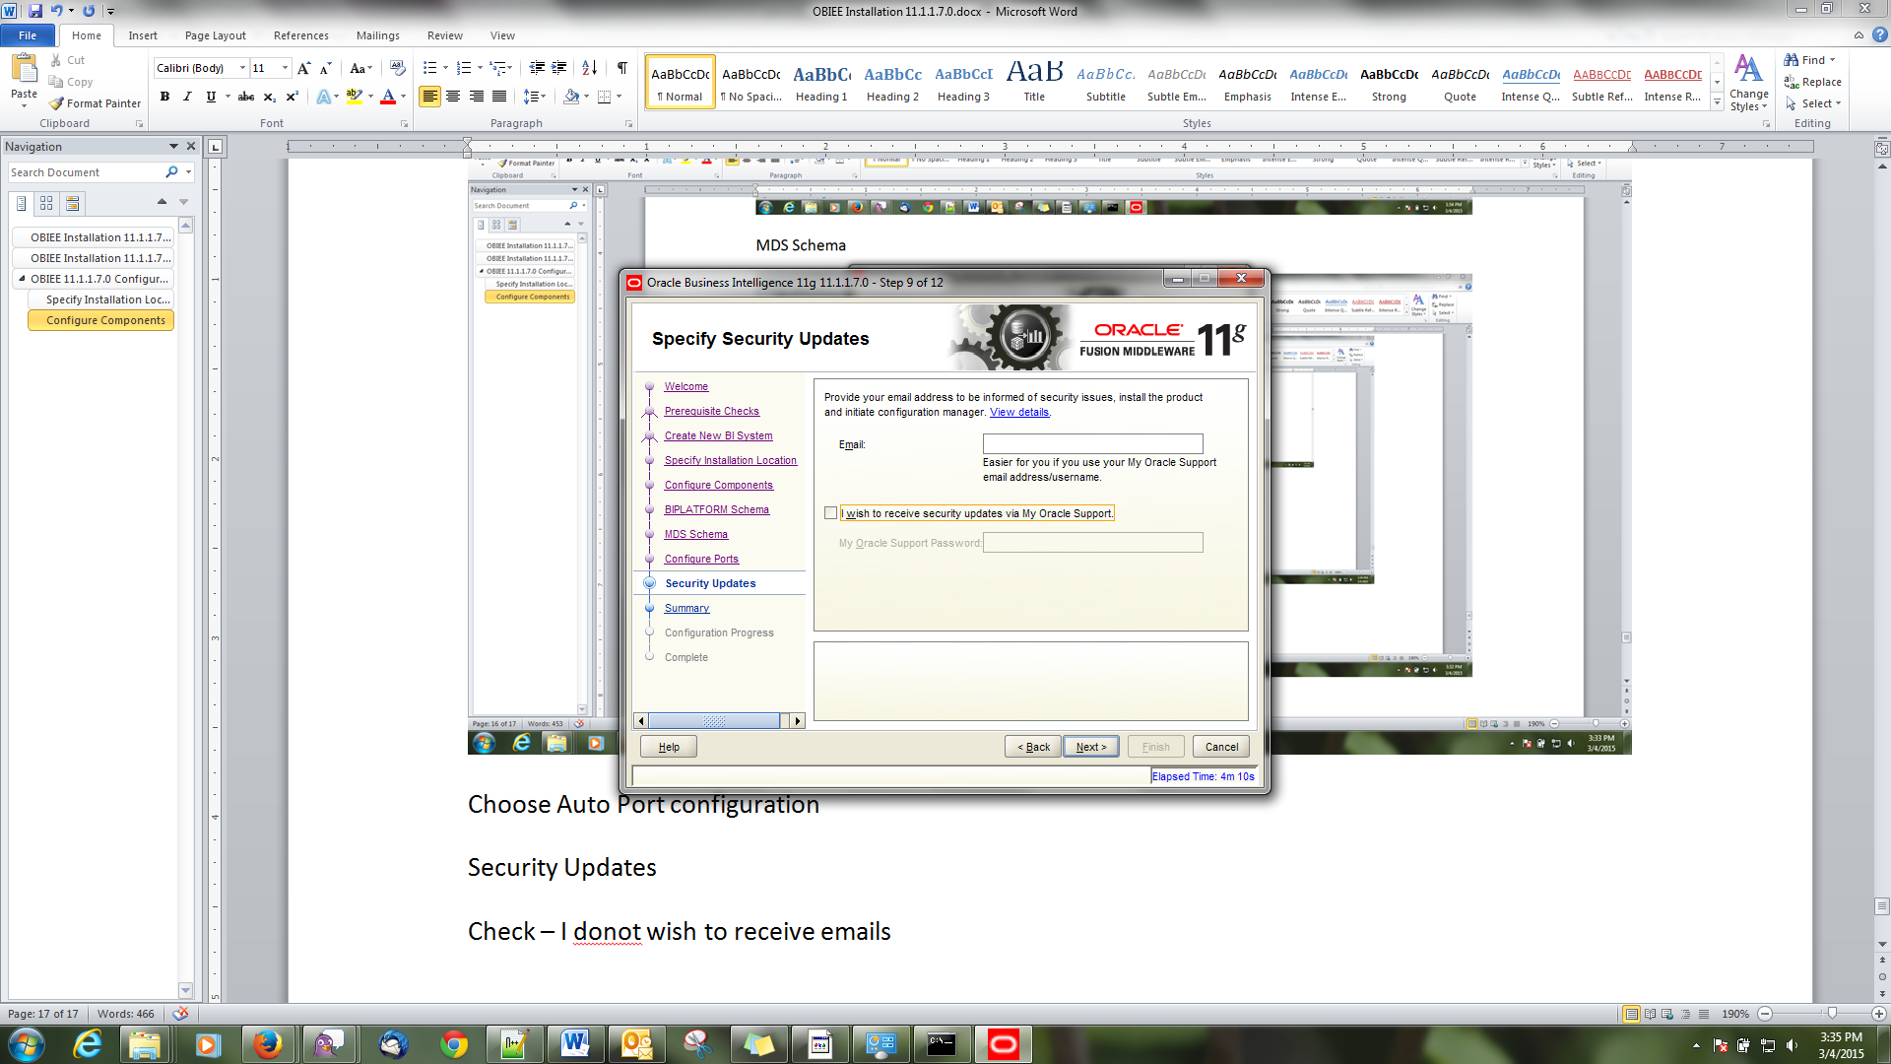

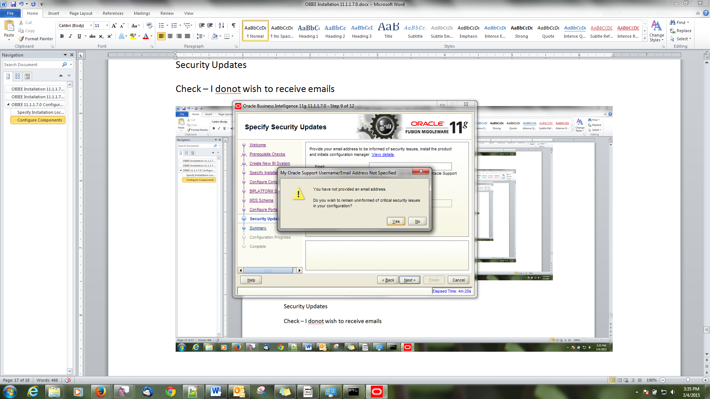

### Summary

Save responses file and click Yes

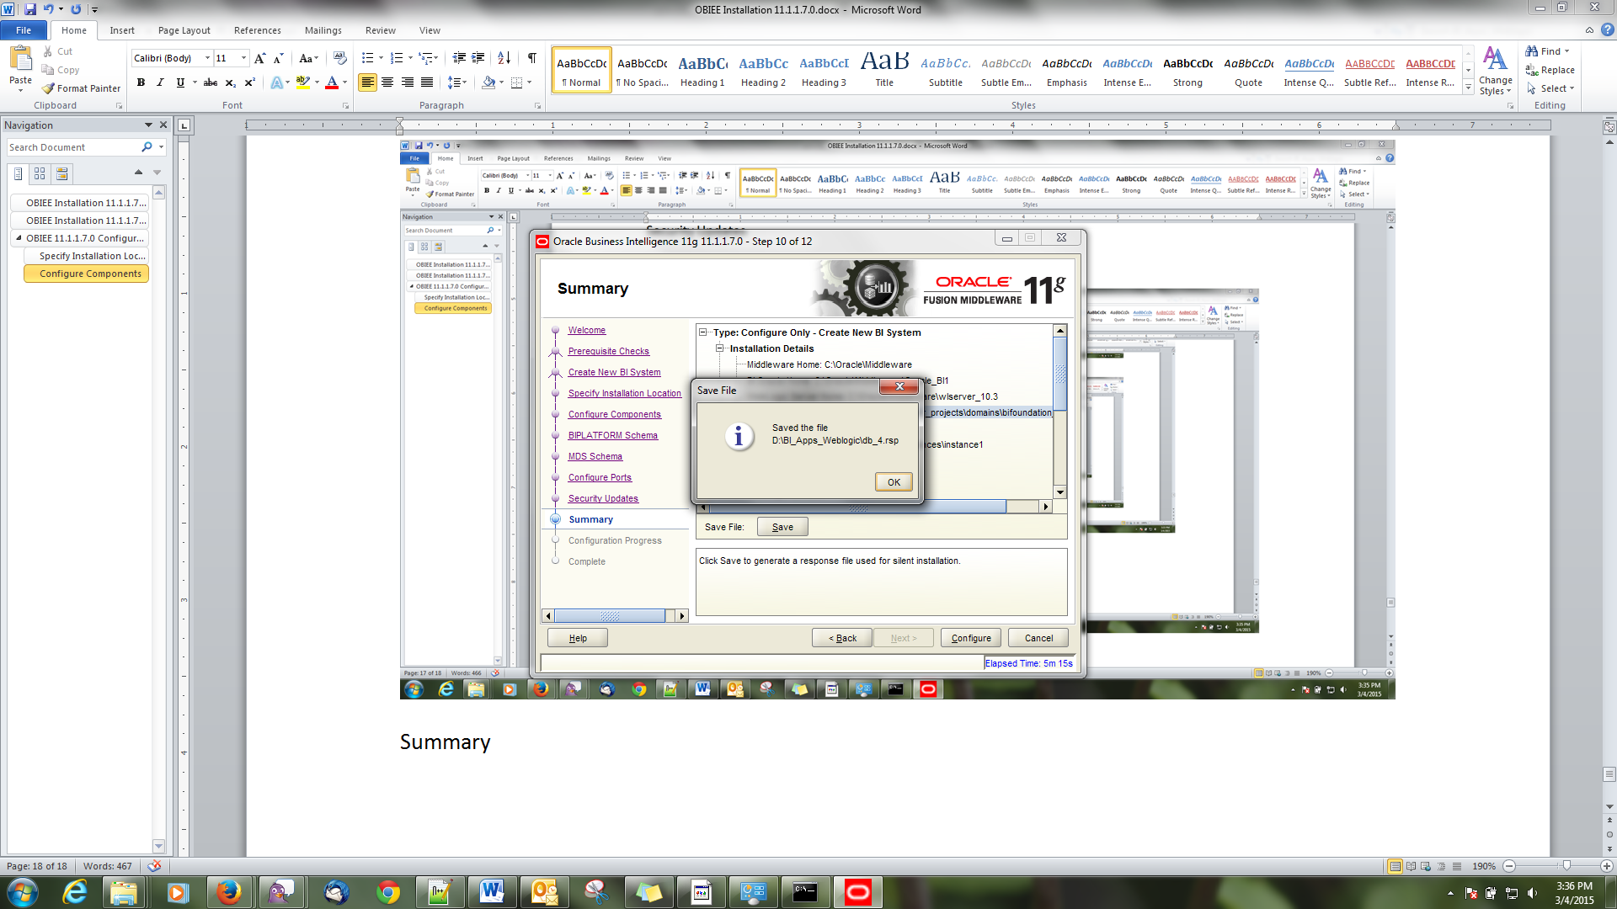

Click configure

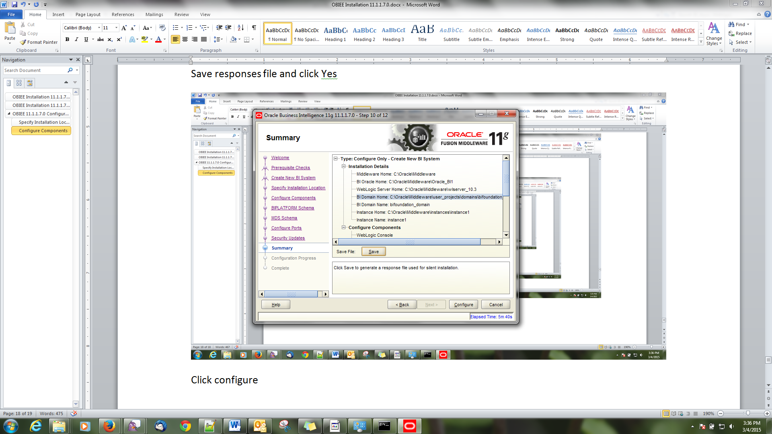

### Configuration Process

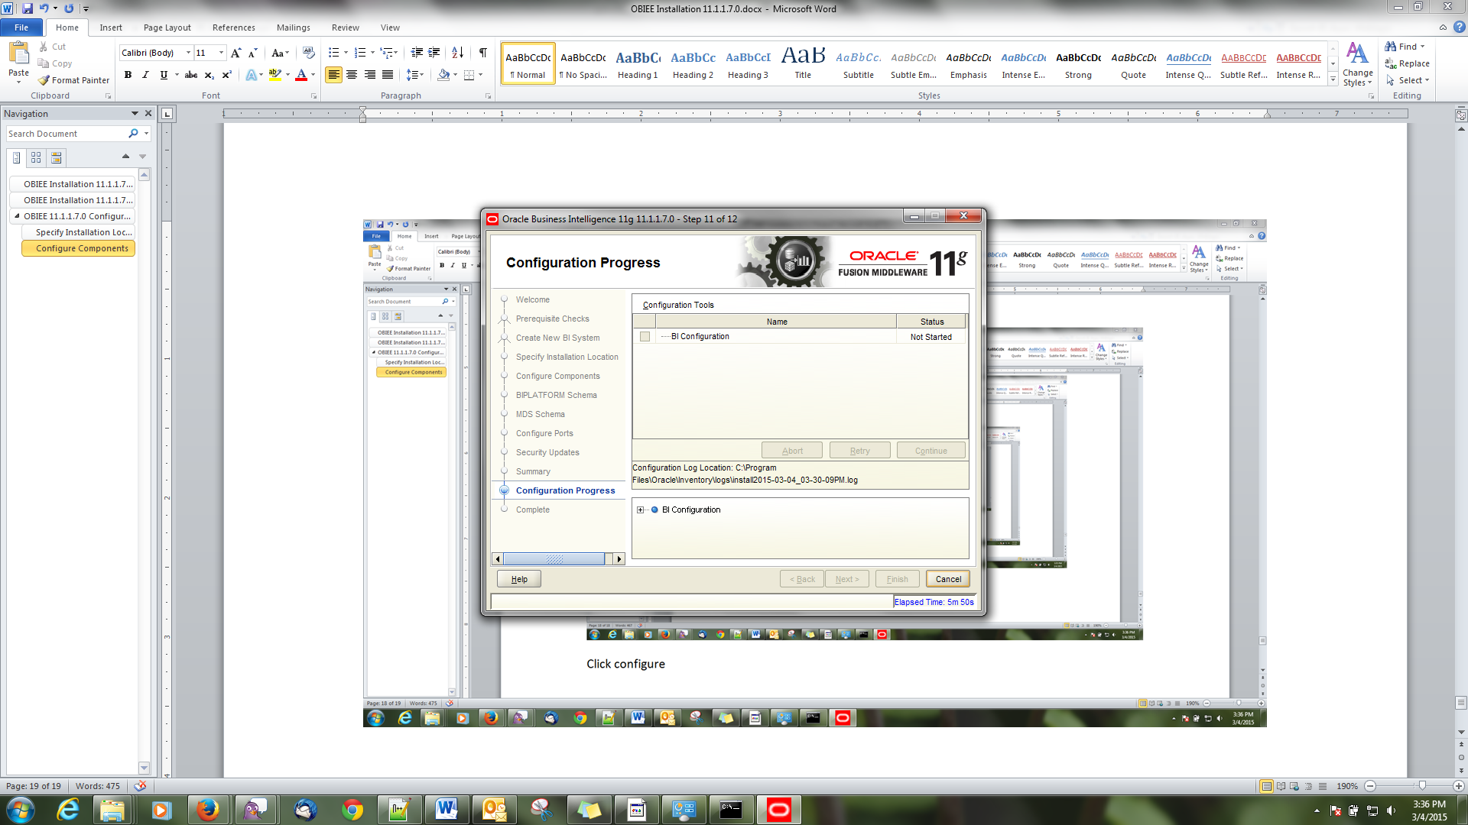

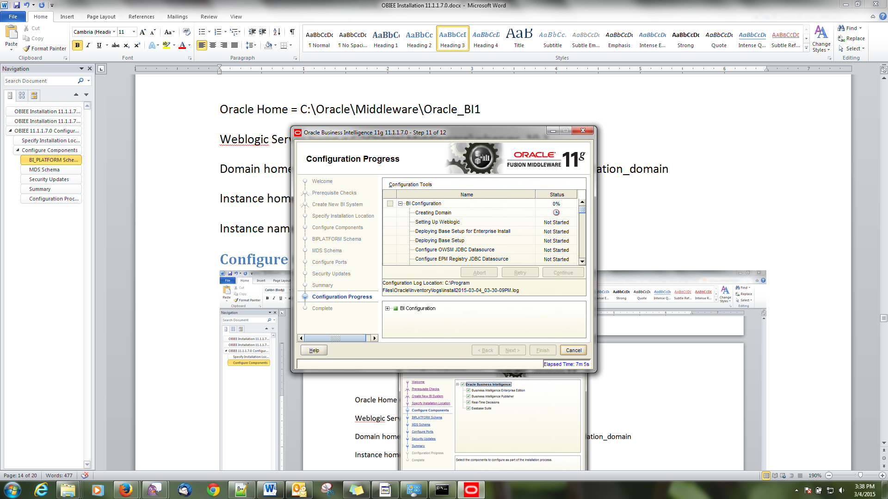

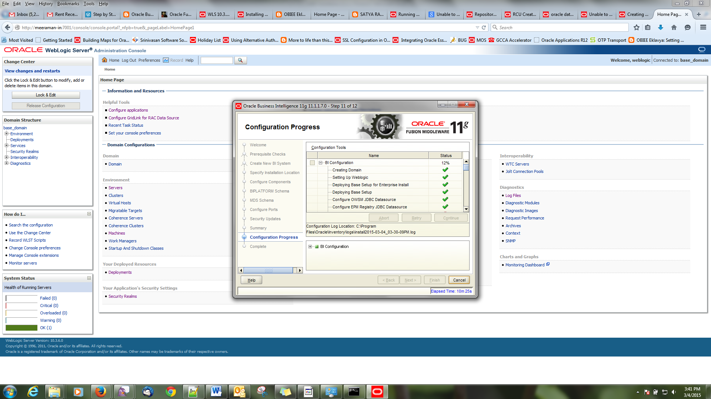

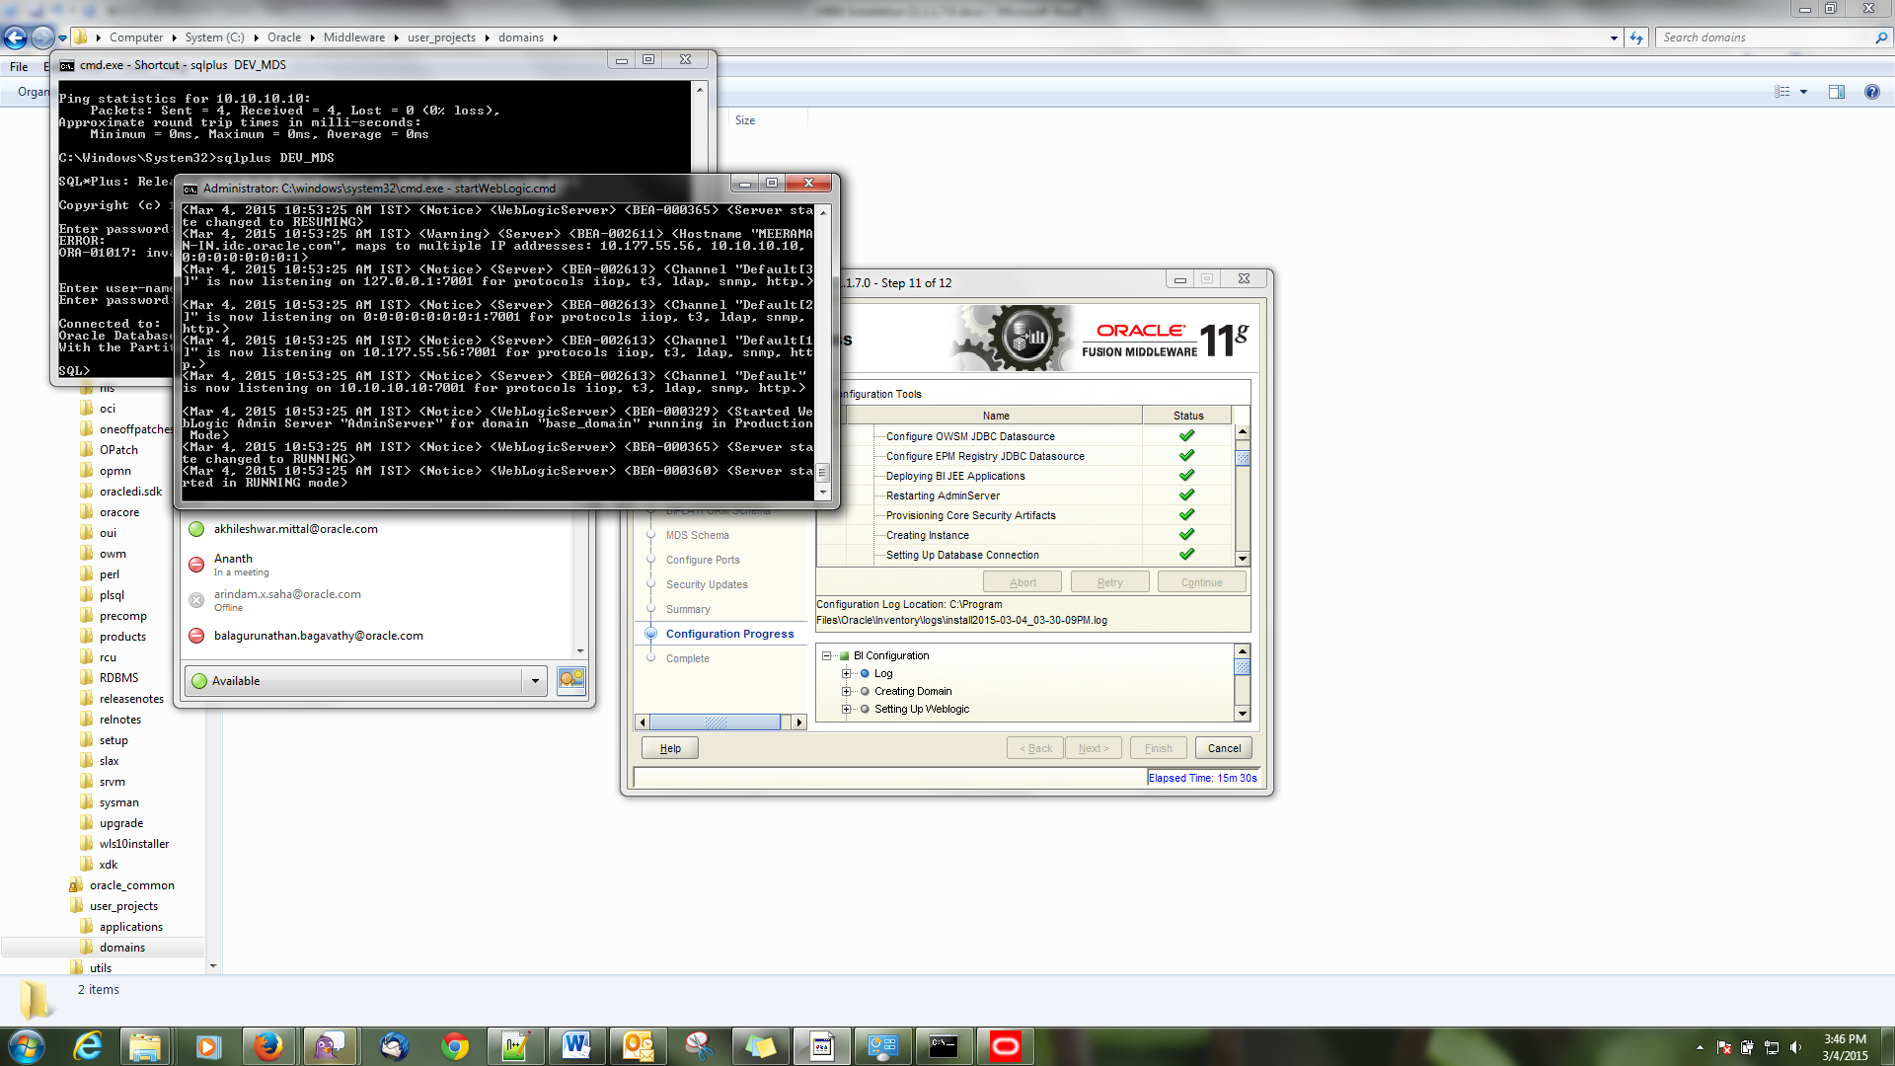

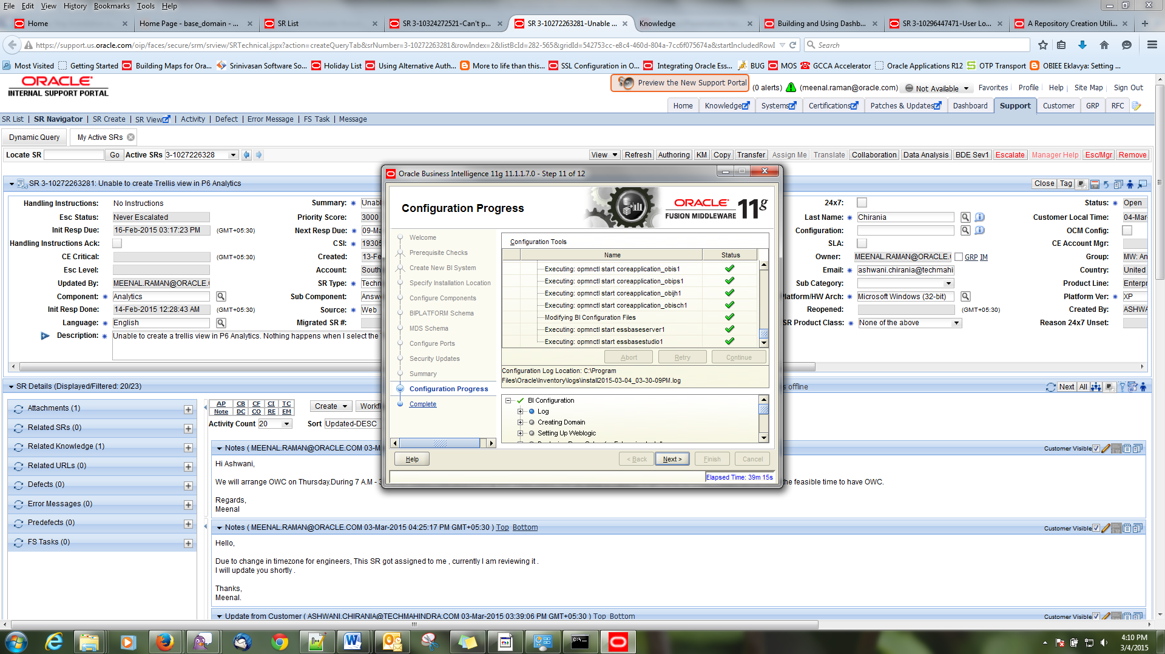

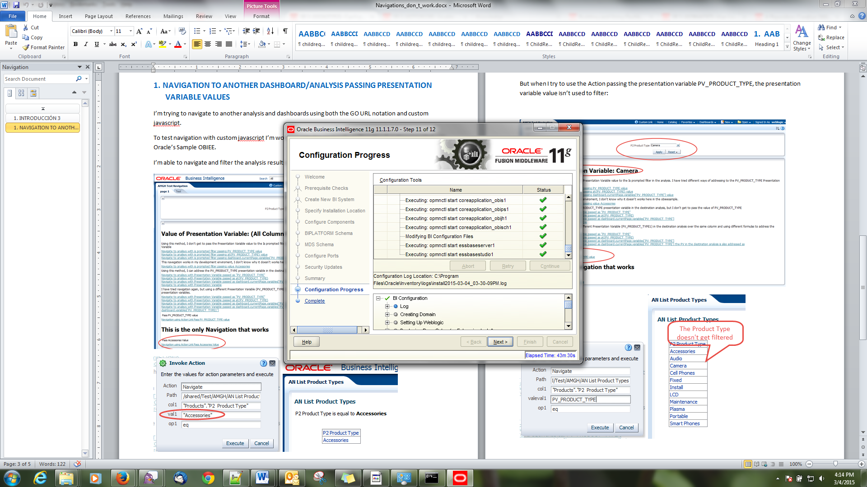

Click Next

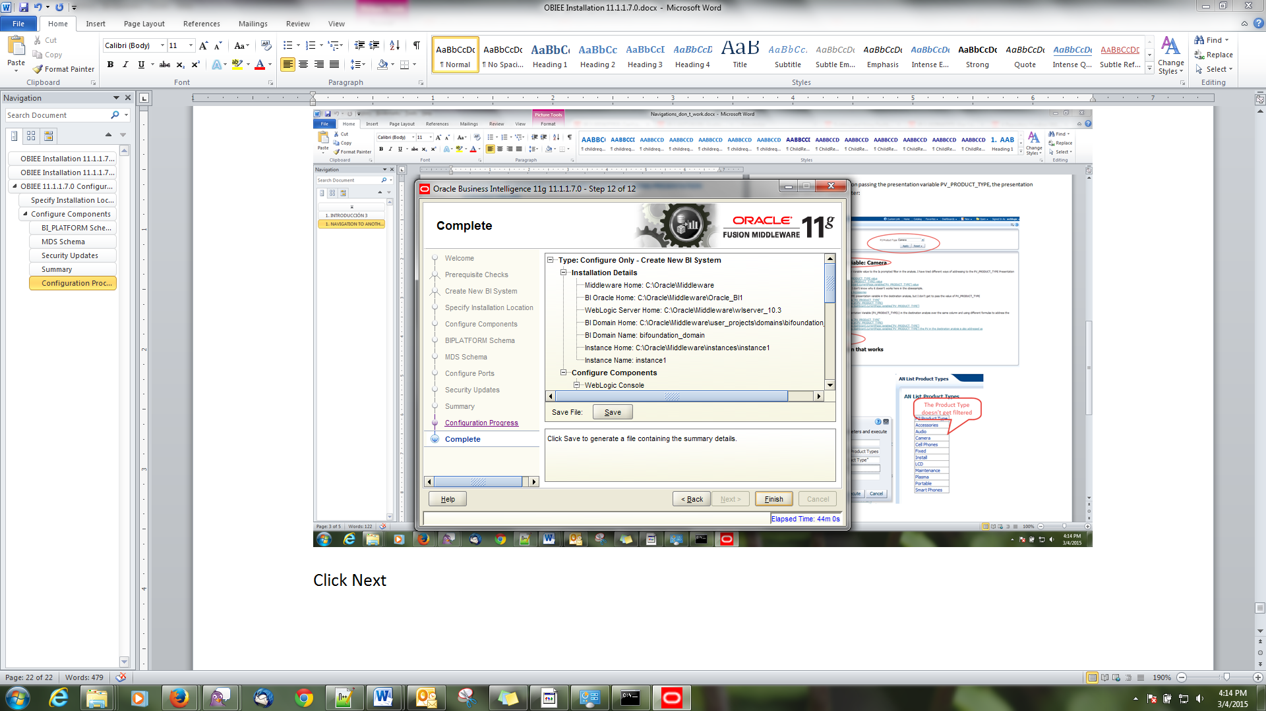

### Complete

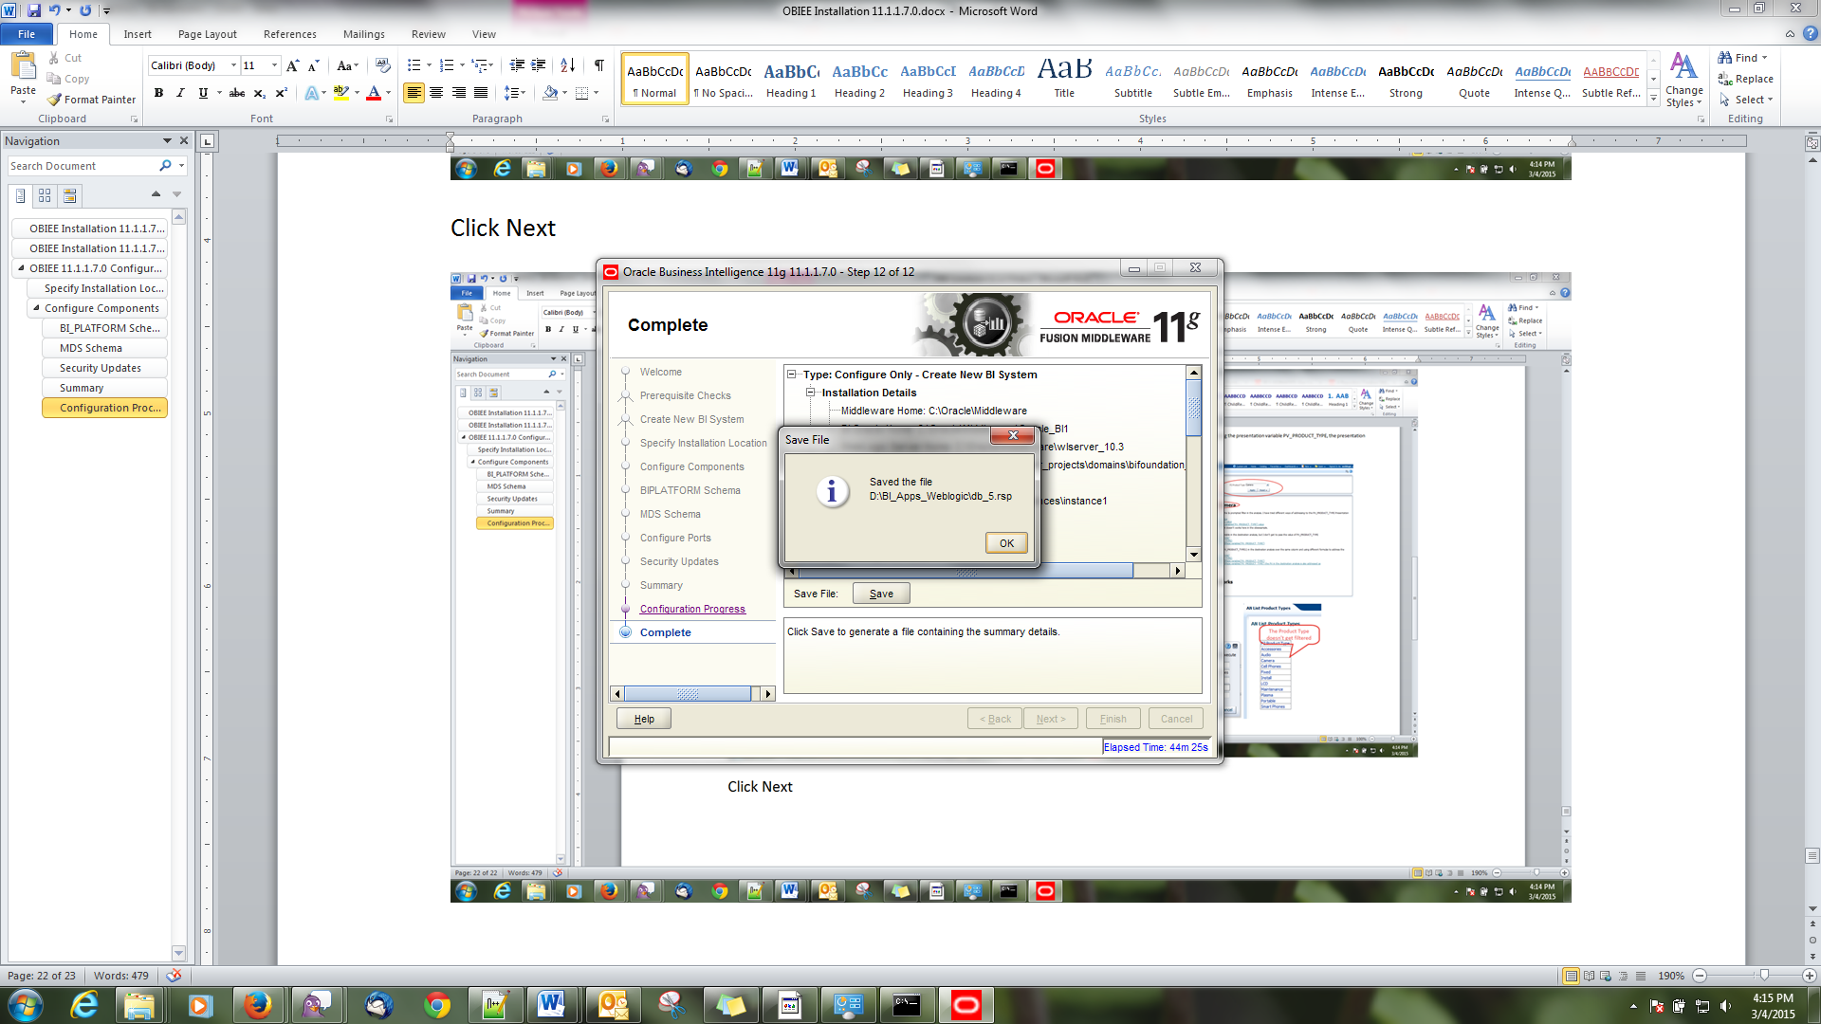

Click Finish

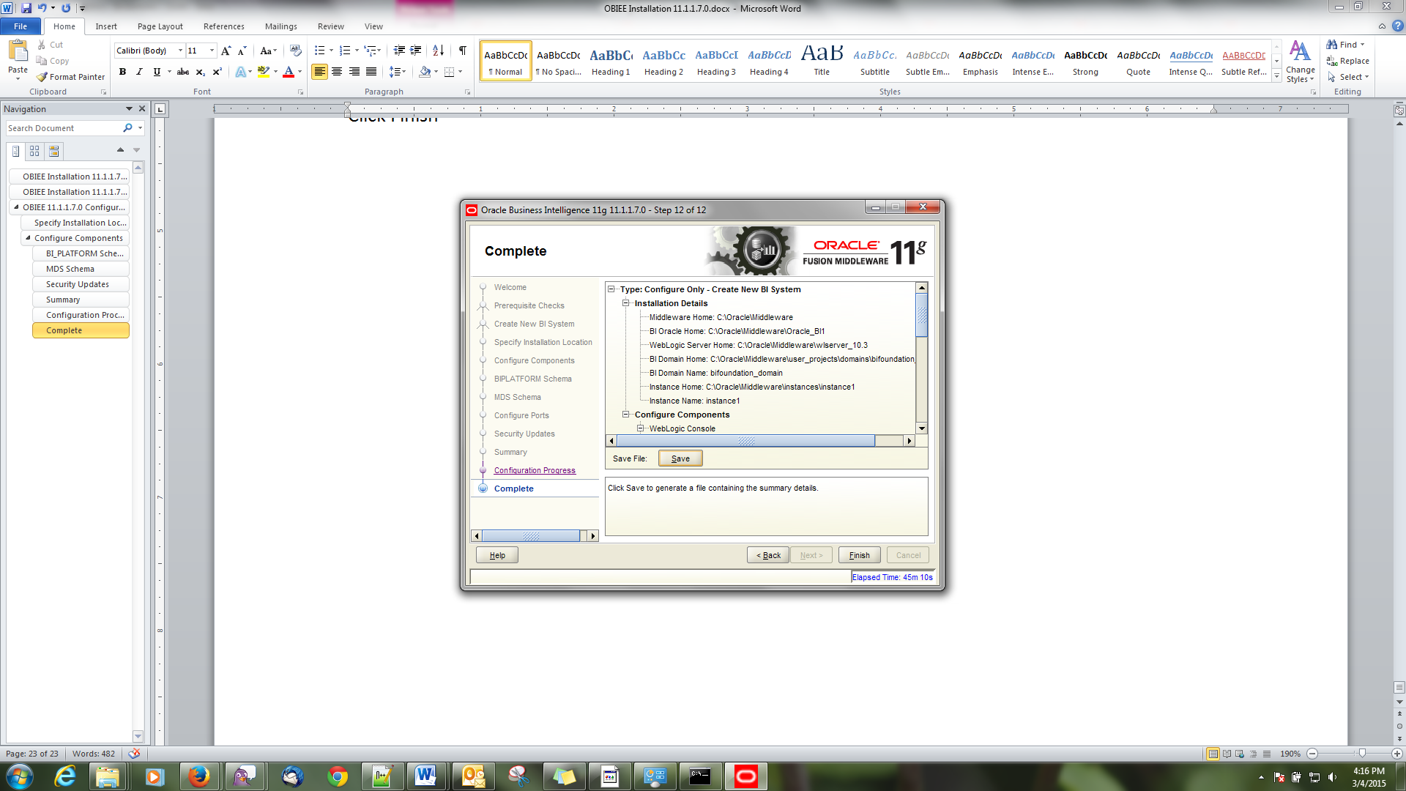

Check whether analytics Url is opening automatically

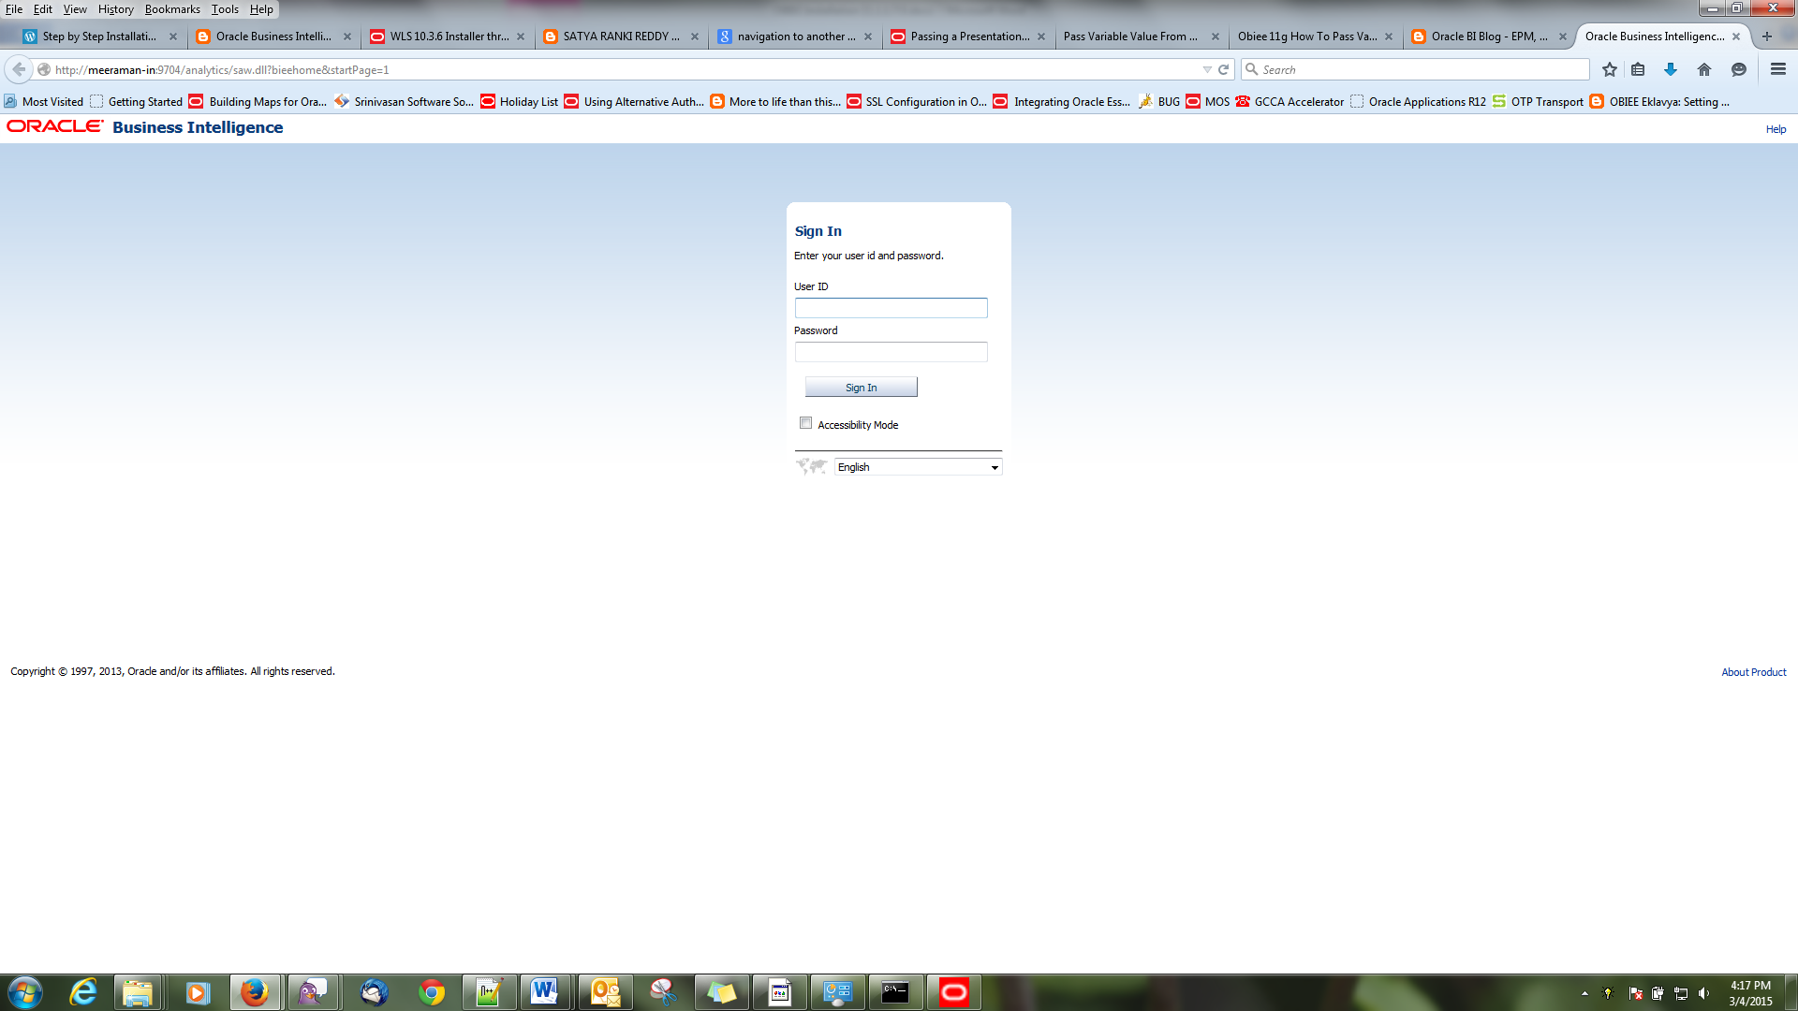

Login with weblogic user

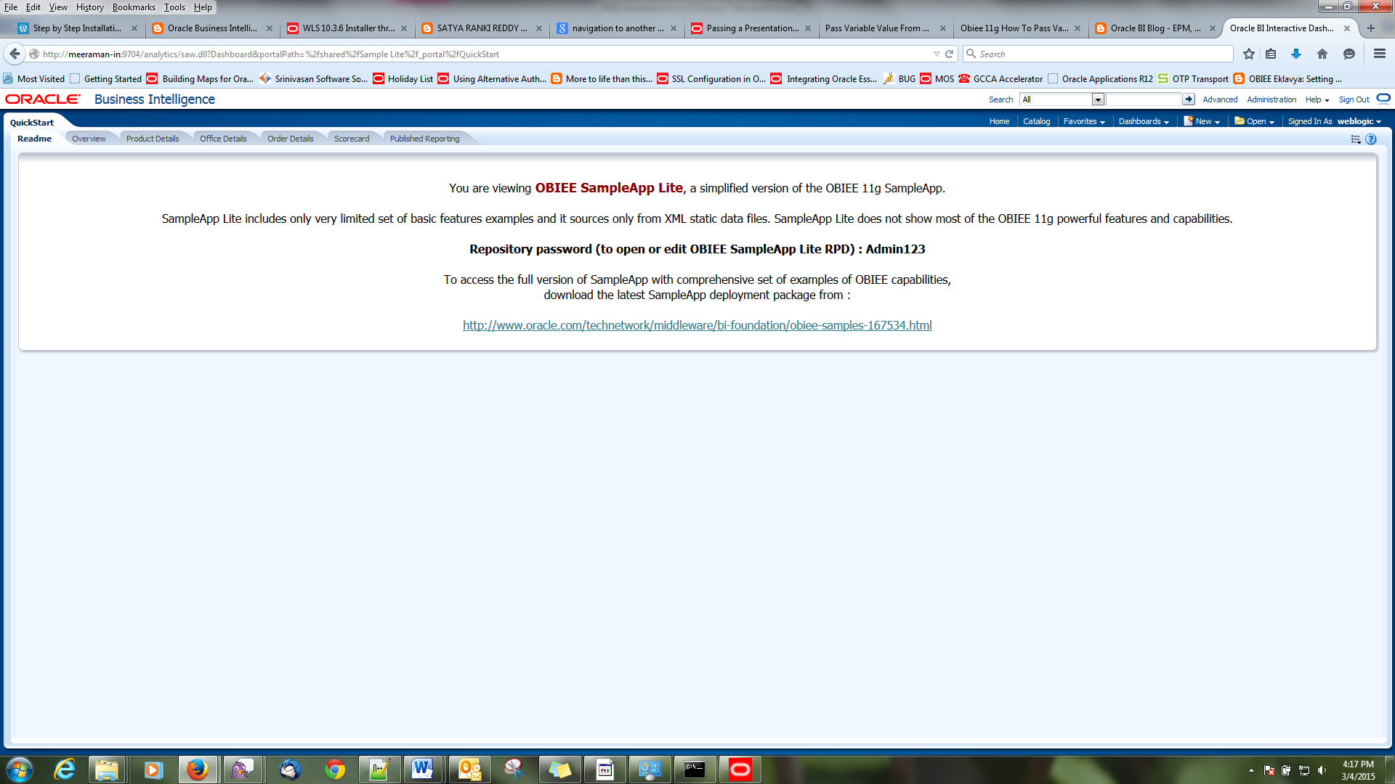

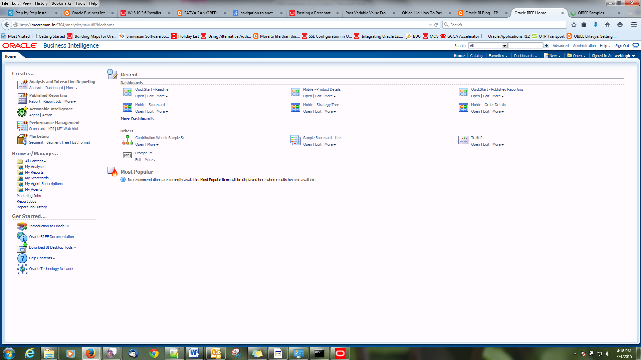

### Console Check

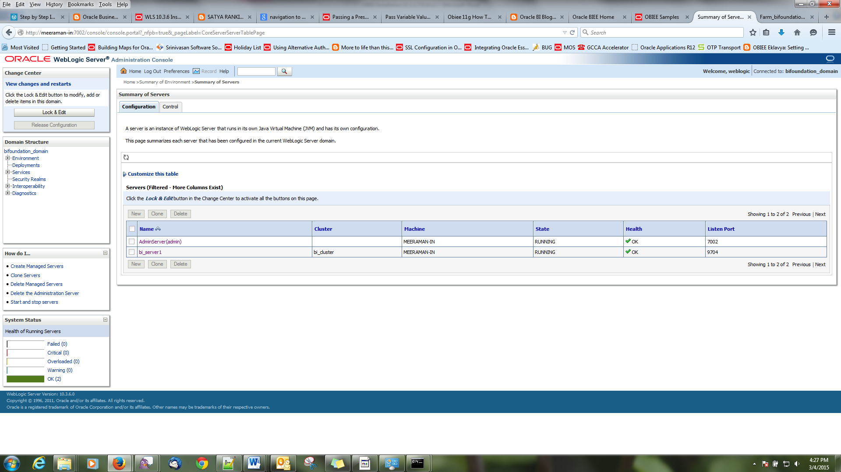

### EM Check

